Abstract

In this document we are presenting the requirements specification for an online ordering system designed primarily for use in the food delivery industry. Our system will allow restaurants to quickly and easily manage an online menu which customers can browse and use to place orders with just a few clicks. The system then relays these orders to restaurant employees through an easy to navigate graphical interface for efficient processing.

Described within the document is an overall model of the system, outlines of functional and non-functional requirements, and a detailed description of the user interface. Finally, the document presents an account of the evolution of the system along with anticipated maintenance.

Traditional System

A Restaurant is a business which prepares and serves foods and drinks to customer in exchange for money either paid before the meal, after the meal or with an open account .Restaurants serves all the major meals such as breakfast lunch and dinner.

Restaurants vary greatly in appearance and offering including a wide variety of service model ranging from in expensive fast food restaurants and cafeterias to mid price family restaurants to high price luxury establishment.

Traditionally, every Restaurants use man power to run their system where waiters take order and cashier handle the billing part. All works are done using paper and pen .In the former case waiter usually wears casual clothing. In the later case depending on the culture and local tradition, waiter might wear semi-casual, semi-formal or formal wear .Typically at mid to high price restaurants, customer sit at tables, their order are taken by waiters to bring the food when it is ready. After eating the customer then pay the bill.

In some Restaurants such as workplace cafeterias there are no waiters, the customer use tray on which they place cold items that they select from the refrigerated container and hot items which they request from cooks and they pay a cashier before they sit down.

Another restaurants approach which uses few waiters in the buffet restaurants customer serves food on to their own plates.

Introduction

In today’s age of fast food and take-out, many restaurants have chosen to focus on quick preparation and speedy delivery of orders rather than offering a rich dining experience. Until very recently, all of these delivery orders were placed over the phone, but there are many disadvantages to this system, including the inconvenience of the customer needing to have a physical copy of the menu, lack of a visual confirmation that the order was placed correctly, and the necessity for the restaurant to have an employee answering the phone and taking orders.

What I propose is an online ordering system, originally designed for use in college cafeterias, but just as applicable in any food delivery industry. The main advantage of my system is that it greatly simplifies the ordering process for both the customer and the restaurant. When the customer visits the ordering webpage, they are presented with an interactive and up-to-date menu, complete with all available options and dynamically adjusting prices based on the selected options. After making a selection, the item is then added to their order, which the customer can review the details of at any time before checking out. This provides instant visual confirmation of what was selected and ensures that items in the order are, in fact, what was intended.

This system also greatly lightens the load on the restaurant’s end, as the entire process of taking orders is automated. Once an order is placed on the webpage, it is entered into the database and then retrieved, in pretty much real-time, by a desktop application on the restaurant’s end. Within this application, all items in the order are displayed, along with their corresponding options and delivery details, in a concise and easy to read manner. This allows restaurant employees to quickly go through the orders as they are placed and produce the necessary items with minimal delay and confusion.

Online food ordering is a process of ordering food from a local restaurant or food cooperative through a web page or app. Much like ordering consumer goods online, many of these allow customers to keep accounts with them in order to make frequent ordering convenient. A customer will search for a favorite restaurant, usually filtered via type of cuisine and choose from available items, and choose delivery or pick-up. Payment can be amongst others either by credit card or cash, with the restaurant returning a percentage to the online food company.

Self Ordering System for Restaurant is a system that applies in a ordering service. Customer can order their food items online through the website easily. It provides them the convenient way to place the order from anywhere in India.

Independent online food ordering companies offer two solutions. One is a software service whereby restaurants purchase database and account management software from the company and manage the online ordering themselves.

The other solution is an internet-based service whereby restaurants sign contracts with an online food ordering website that may handle orders from many restaurants in a regional or national area.

One difference between the systems is how the online menu is created and later updated. Managed services do this via phone or email, while unmanaged services require the customer to do it. Some websites use wizards to find the best-suited menu for the customer.

Food cooperatives also allow consumers the ability to place an order of locally grown and/or produced food online. Consumers place an order online based on what is available for the ordering cycle (month, week) and then pick up and pay for their orders at a central location. For this system there will be a system administrator who will have the rights to enter the menu with their current prevailing prices. He/she can enter anytime in the system by a secured system password to change the menu contents by adding or deleting an item or changing its price.

Now when the customer will place his order till the payment confirmation. He will select from the food options according to his choice and the system will display the payment amount he has to make once he has finished with his order. He will have the option of paying the bill by cash, debit card or a credit card. The user will slide his card and the system will check for the validity of the card and the payment will be made. A receipt will be printed containing the order number and the order will be sent in the kitchen for processing.

# System Model

The structure of the system can be divided into three main logical components. The first component must provide some form of menu management, allowing the restaurant to control what can be ordered by customers. The second component is the web ordering system and provides the functionality for customers to place their order and supply all necessary details. The third and final logical component is the order retrieval system. Used by the restaurant to keep track of all orders which have been placed, this component takes care of retrieving and displaying order information, as well as updating orders which have already been processed.



System Modeling and Analysis

* ***System Behavior***

System behavior shows what a system does or appears to do; it’s represented graphically by a model which integrates the functional model and the inputs and outputs. We represent the model through diagrams called “Functional Flow Block Diagram” (FFBD).The figures below show functional models.

* ***FFBD of whole system***

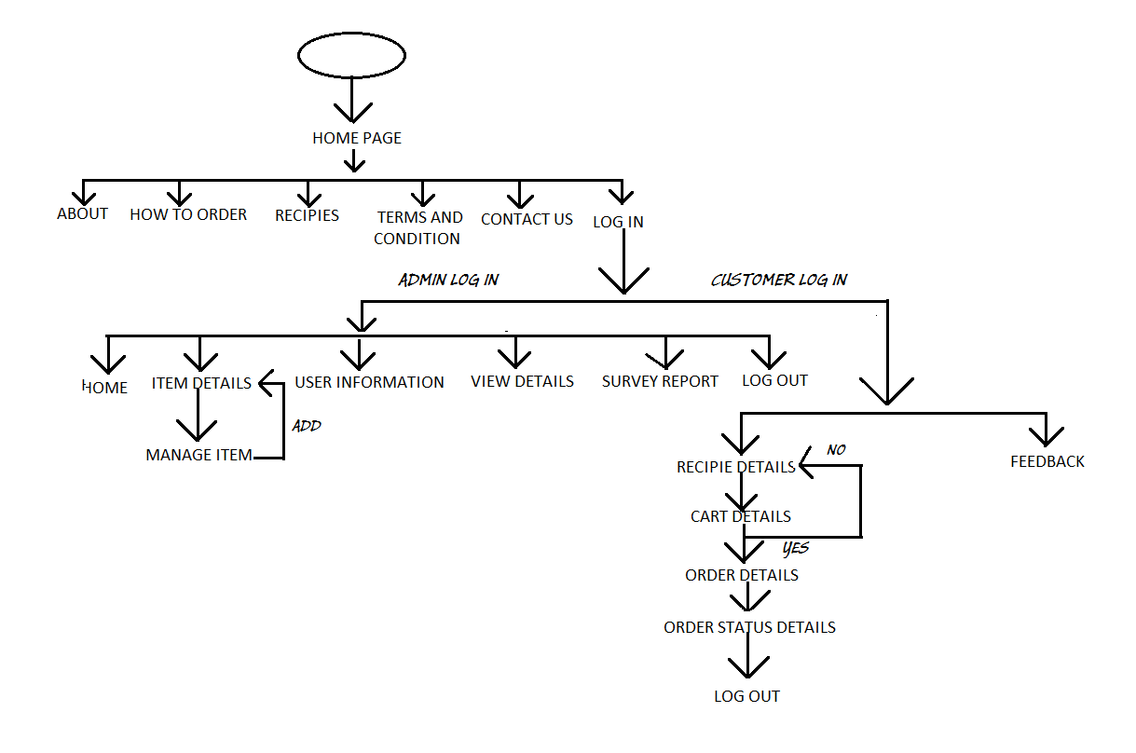

Anticipated Benefits

1. This will minimize the number of employees at the back of the counter.
2. The system will help to reduce the cost of labor.
3. The system will be less probable to make mistake, since it is a machine.
4. This will avoid long queues at the counter due to the speed of execution and number of optimum screens to accommodate the maximum throughput.
5. The system will be available 24 hours for 365 days, because the machine is not going to take any sick or vacation leave.

Drawbacks

1. It is not meant for illiterate people.
2. No connection due to System Failure.
3. Sever could be busy as no. of users increases.

Goals and Scenarios

**Goal 1.**The system has a user-friendly user interface.

1. Scenario 1.1. A particular user of the system has no difficulty in reading the text on the display.
2. Scenario 1.2. The system is navigable through intuition.
3. Scenario 1.3. Menu choices are presented in form of buttons, which contain text as well as little pictures illustrating the choice for better understanding.

**Goal 2.**System takes order from the customer as per his/her choice.

1. Scenario 2.1. User selects a combo deal (i.e. a combination of main food, drink and side dish).
2. Scenario 2.2. User may want to make up his own order by selecting dishes.

**Goal 3.**The system calculates and displays the final bill based on the placed order.

1. Scenario 3.1. System calculates final bill based on the quantity of the items multiplied by their unit price topped up by the applicable taxes if any.
2. Scenario 3.2. User is given the option to either pay for the order or revise the order.

**Goal 4.**System handles the payment for the user-defined order.

1. Scenario 4.1: User decides to pay cash and system asks user to enter cash in the slot.
2. Scenario 4.2: System verifies the cash amount and gives refund if any after deducting the amount.
3. Scenario 4.3: User decides to pay through credit/debit card. System informs user to swipe card through card reader.
4. Scenario 4.4: The system verifies the card and charges the amount of the bill to the card. Asks user to sign the bill on the signing pad.
5. Scenario 4.5. The system prints out receipt containing a token number, details of the order, bill and the payment method with a terminal message (Thank you visit again or Store address).
6. Scenario 4.6: System communicates the order to the kitchen through the internal ordering system.

**Goal 5.**System offers the choice to change the menu items to the store manager.

1. Scenario 5.1. Admin decides to add / delete an item from the menu.
2. Scenario 5.2. Admin wants to put festive offers on some items because of which there is a change in the price of some of the items.
3. Scenario 5.3. Admin notices that some dishes are out of stock. Consequently he updates the menu so that those items are deleted temporarily deleted from the display presented to the user.

# Functional Requirements

As can be seen in the system model diagramed above, each of the three system components essentially provides a layer of isolation between the end user and the database. The motivation behind this isolation is twofold. Firstly, allowing the end user to interact with the system through a rich interface provide a much more enjoyable user experience, particularly for the non-technical users which will account for the majority of the system’s users. In addition, this isolation layer also protects the integrity of the database by preventing users from taking any action outside those which the system is designed to handle. Because of this design pattern, it is essential to enumerate exactly which functions a user will be presented and these functions are outlined below, grouped by component.

## The Web Ordering System

Users of the web ordering system, namely restaurant customers, must be provided the following functionality:

* Create an account.
* Manage their account.
* Log in to the system.
* Navigate the restaurant’s menu.
* Select an item from the menu.
* Customize options for a selected item.
* Add an item to their current order.
* Review their current order.
* Remove an item/remove all items from their current order.
* Provide delivery and payment details.
* Place an order.
* Receive confirmation in the form of an order number.

As the goal of the system is to make the process of placing an order as simple as possible for the customer, the functionality provided through the web ordering system is restricted to that which most pertinent to accomplish the desired task. All of the functions outlined above, with the exceptions of account creation and management, will be used every time a customer places an order. By not including extraneous functions, we are moving towards our goal of simplifying the ordering process.

## Menu Management System

The menu management system will be available only to restaurant administrator and will, as the name suggests, allow them to manage the menu that is displayed to users of the web ordering system. The functions afforded by the menu management system provide user with the ability to, using a graphical interface:

* Add a new/delete food category to/from the menu.
* Add a new/delete food item to/from the menu.
* Add a new/delete option for a given food item.
* Update additional information (description, photo, etc.) for a given food item.

It is anticipated that the functionality provided by this component will be one of the first things noted by the restaurant user, as they will have to go through it to configure their menu, etc. before beginning to actually take orders. Once everything is initially configured, however, this component will likely be the least used, as menu updates generally do not occur with great frequency.

## Order Retrieval System

Of the three components, the order retrieval system is functionally the simplest. Like the menu management system, it is designed to be used only by restaurant employees, and provides the following functions:

* Retrieve new orders from the database.
* Display the orders in an easily readable, graphical way.
* Mark an order as having been processed and remove it from the list of active orders.
* ***Overall working***

We describe the basic system functionality with textual use cases, and employ activity diagrams for a visual representation of the corresponding sequence of task or flow of information.

**Use Case 1.**Place Order

* **Primary Actor:**Customer

**Description:**Customer places an order from the available choices after indicating his language preference for the session.   
**Pre-conditions:**System is connected to a power source, display is turned on and system is configured to accept the inputs.

**Flow of Events:**

* 1. User sees menu
  2. User selects from the menu
  3. User add the selected to cart
  4. User confirms the order
  5. User choose payment type

**Alternative Flow of Events:**

* + 1. User accidentally presses a wrong button and after realizing it he hits the backspace button.
    2. User enters a wrong order and wants to go back to the main menu.

**Post-condition:**Order has been made that goes to the admin who then instruct his employee to so their specific work.  
**Assumption:**User is familiar with how to enter values and has a general idea why the inputs are being provided and what is expected out of system.

**Use Case 2.**Update Menu.

* **Primary Actor:**Administrator

**Description:**The menu might change according to the inventories or add/delete items from menu and deals. The prices of each item might change for the period of time.   
**Pre-condition:**An order menu with their respective price already exists in the system in some particular format.   
**Flow of Events:**

* 1. The Admin enters the system with some password.
  2. The Admin makes the required changes.
  3. The Admin saves the changes and logs out.

**Alternative Flow of Events:**

* 1. Some of the menu might not need any change.
  2. User might enter invalid password and need to go back.

**Post-condition:**A menu list will be displayed when the user enters the system.

**Assumption:**The Admin is given the rights and privileges to enter the system and make the required changes.

**Use Case 3.**Read Order.

* **Primary Actor:**Administrator

**Description:**Internal order system reads the order once the customer confirms his order and then he communicates the order to the food preparation person.

**Pre-condition:**User confirms the order.   
**Flow of Events:**

* 1. Internal order system reads the order
  2. Communicates the order to the food preparation person

**Post-condition:**The final order is being processed in the kitchen.   
**Assumption:**Food preparation person is available to take the order and know the sequence of processing the orders.

# User Interface Specifications

Each of the system components will have their own unique interface. These are described below.

## Web Ordering System

Users of the web ordering system will interact with the application through a series of simple forms. Each category of food has its own form associated with it for choosing which specific item from the category should be added to the order, and buttons for selecting which options are to be included. Adding an item to the order is accomplished by a single button click. Users select which category of food they would like to order, and therefore which form should be displayed, by navigating a menu bar, an approach which should be familiar to most users.

Entering delivery and payment deals is done in a similar manner. The user is presented with a form and must complete the required fields, which include text boxes, before checking out and receiving a confirmation number. One thing worth noting here is that whenever possible buttons were used over freeform input in order to both simplify the ordering process and reduce the possibility of SQL injection attempt.

## Menu Management System

User interaction with the menu management system is similar to that with the web ordering system. Users navigate a structure to find a category, or specific food item that they would like to modify and after making their selection they are presented with a form which displays all of the current fields and values associated with that item, all of which can be modified or removed. The form also presents buttons which allow the addition of new fields and values. This does not raise a major concern though, as input sanitation will be performed, and the user, who is assumed to be a restaurant employee, is less likely to be malicious than a web user.

## Order Retrieval System

User interaction with the order retrieval will be very simple. The application will automatically fetch new orders from the database at regular intervals and display the order numbers, along with delivery time, in a panel of the application. To view the details of an order, the user must simply click on that order number, which will populate the panel with the details, displayed in an easy to read and navigate structure.

# Non-functional Requirements

Because the design patterns of the Online Ordering System are pretty much the standard for a web application, the non-functional requirements of the system are very straightforward. Although written using Visual Studio 2012, the application is compiled to ASP.NET, along with a C# backend, all of which are supported by any reasonably well maintained web server.

All of the application data is stored in a Microsoft SQL Server database, and therefore a Microsoft SQL Server must also be installed on the host computer. As with IIS, this software is freely available and can be installed and run under most operating systems.

The server hardware can be any computer capable of running both the web and database servers and handling the expected traffic. For a restaurant that is not expecting to see much web traffic, or possibly doing only a limited test run, an average personal computer may be appropriate. Once the site starts generating more hits, though, it will likely be necessary to upgrade to a dedicated host to ensure proper performance. The exact cutoffs will need to be determined through a more thorough stress testing of the system.

# System Evolution

As mentioned in the system model, at the heart of the entire ordering system is the database. In fact, the system could be completely operational using nothing but the database and an appropriate shell utility, assuming that all users are well-versed in SQL and enjoy using it to order food. While this would be a bit extreme, it does illustrate the point that the one part of the system which will stay relatively constant is the database. On the other hand, it is very probable that the other components will continue to evolve with time. For example, with the booming popularity of mobile applications, we would really like to make the web interface available as a phone application as well. Also it may make sense to at some point migrate the menu management and order retrieval systems to web, or even mobile, applications as well, as some users may prefer to use them as such.

We are also certain that if this system goes into actual use, many requests will arise for additional features which we had not previously considered, but would be useful to have. For this reason, we feel as though the application can be constantly evolving, which we consider a very good thing.

ER Diagram

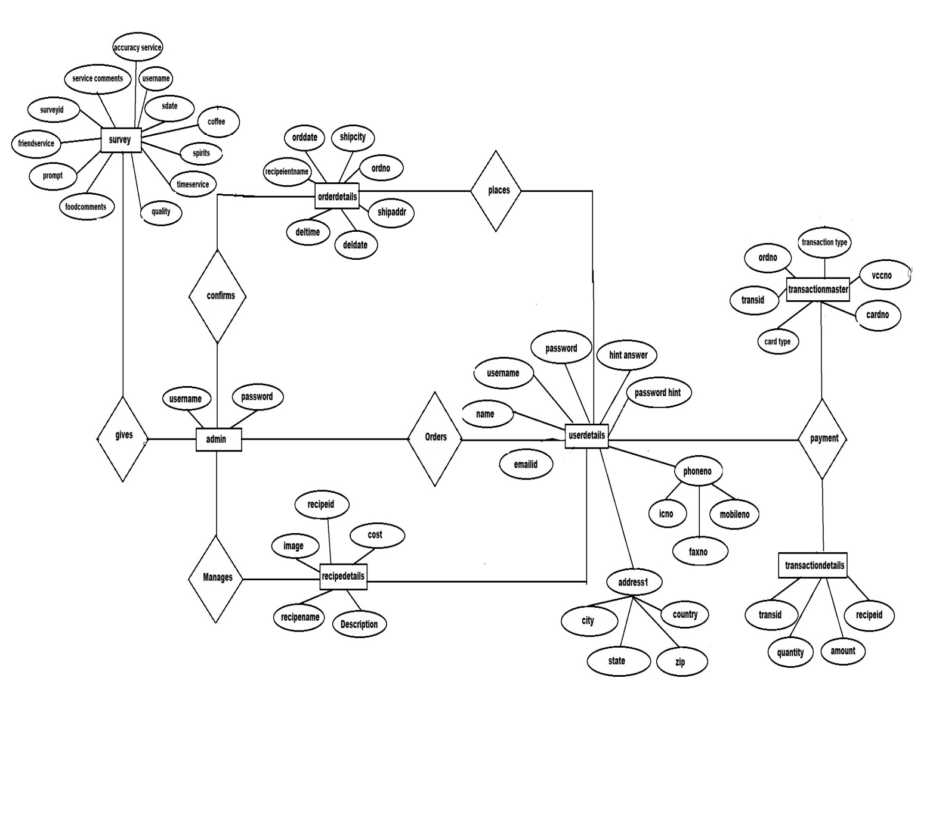

SCREENSHOTS

* ***Home Pages***

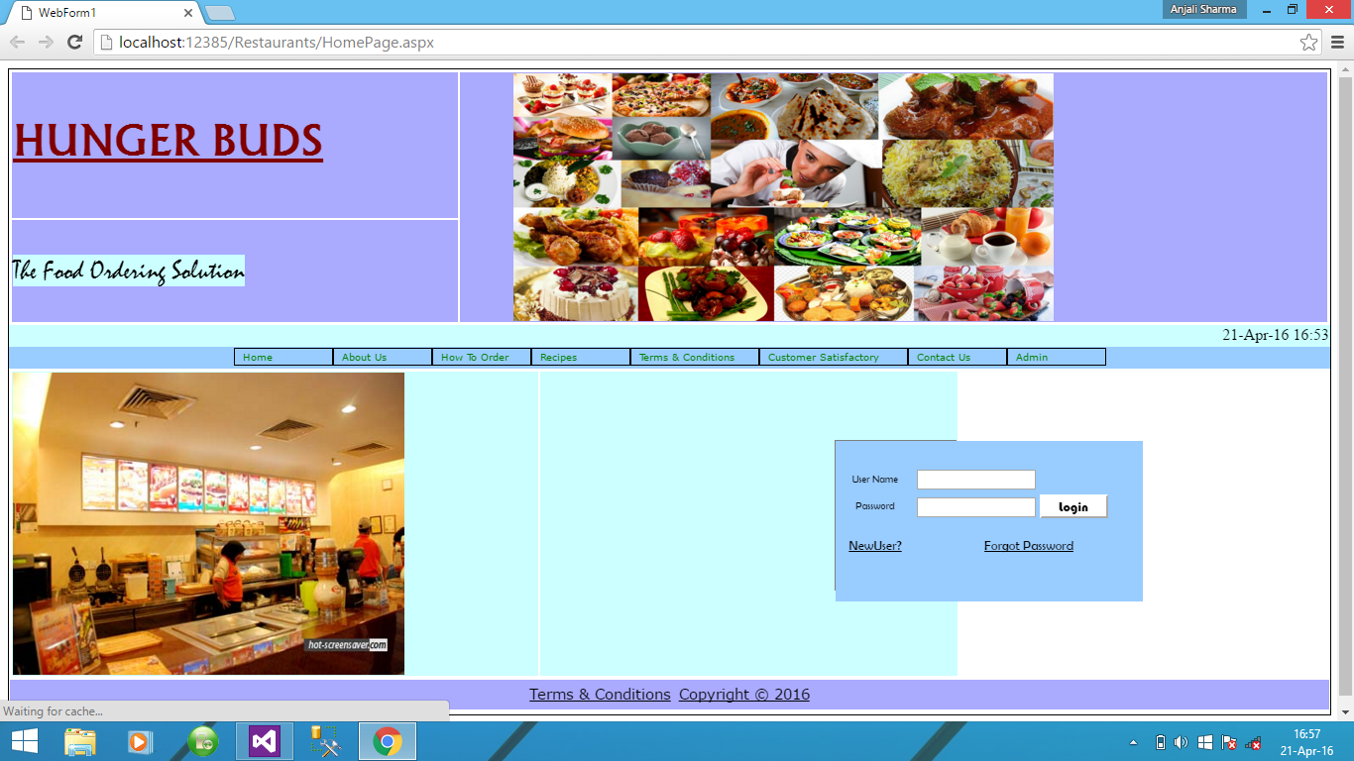

* ***About Us***

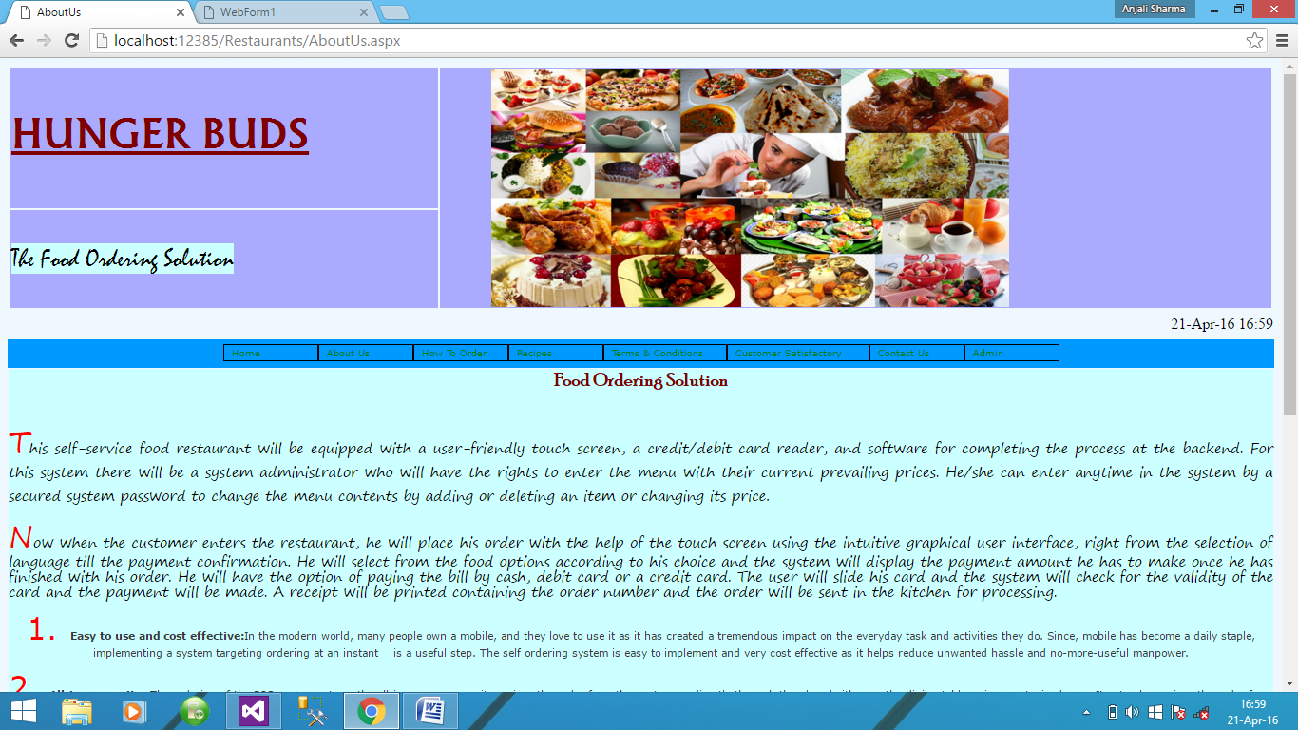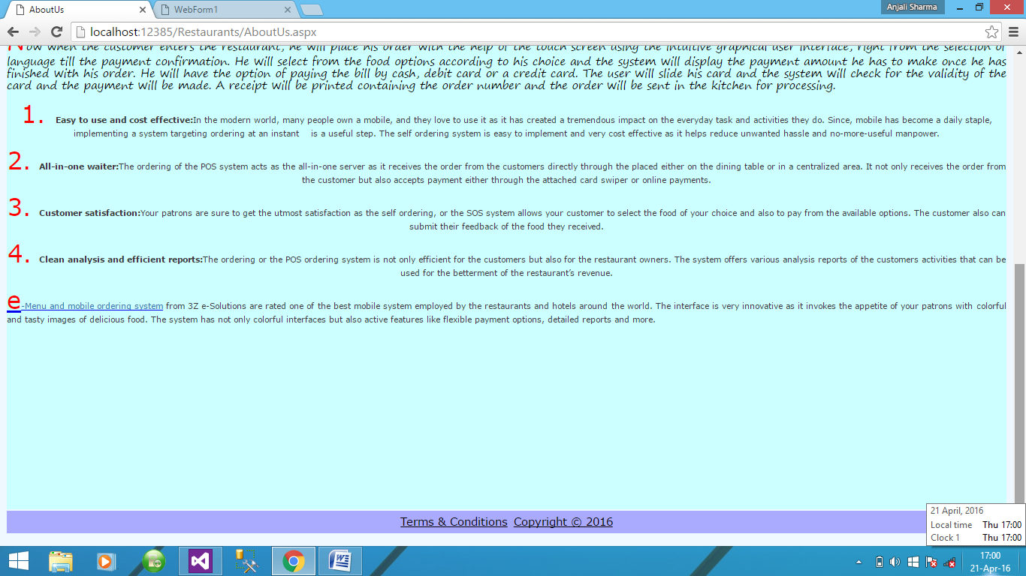

* ***How to Order***

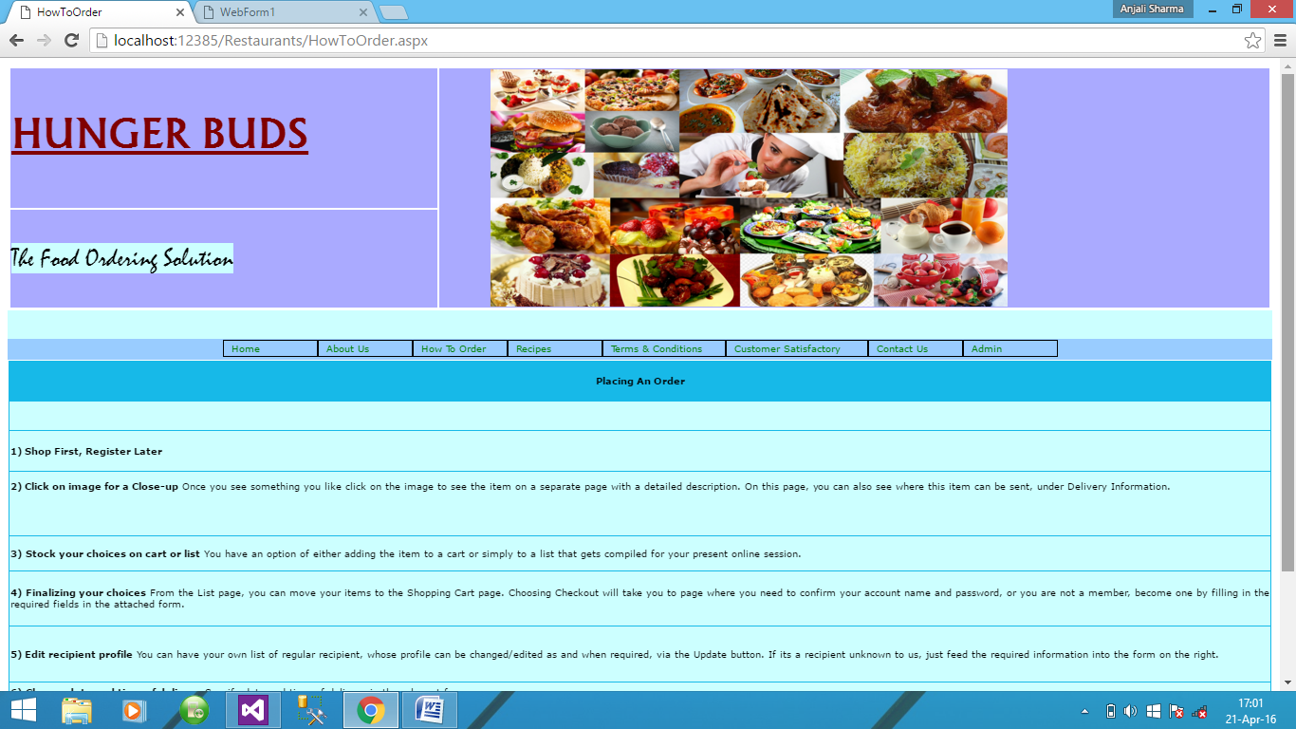…

Customer LogIn

* ***Recipe Details***

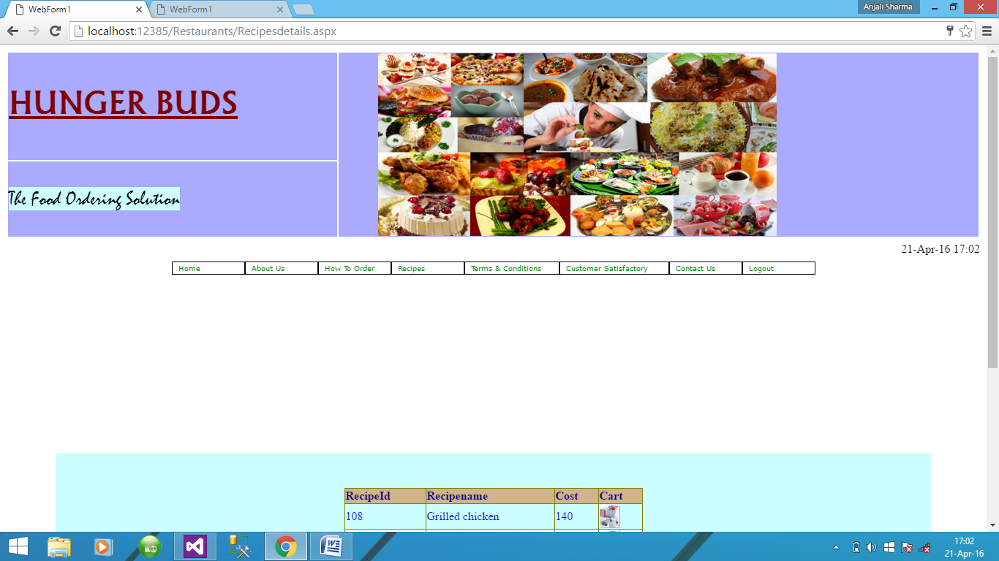

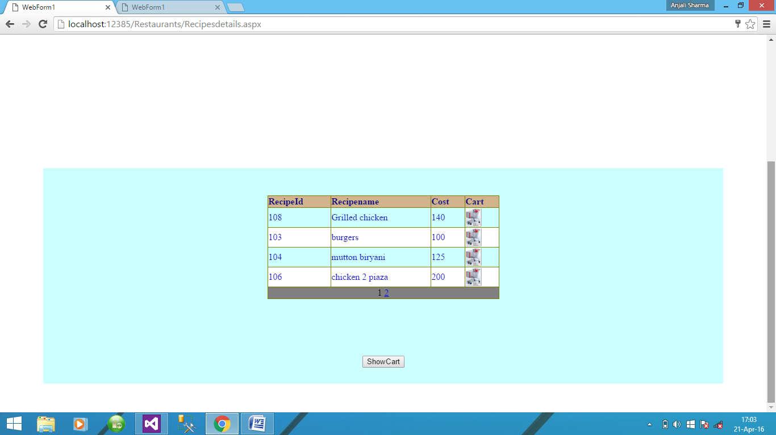

* ***Feedback***

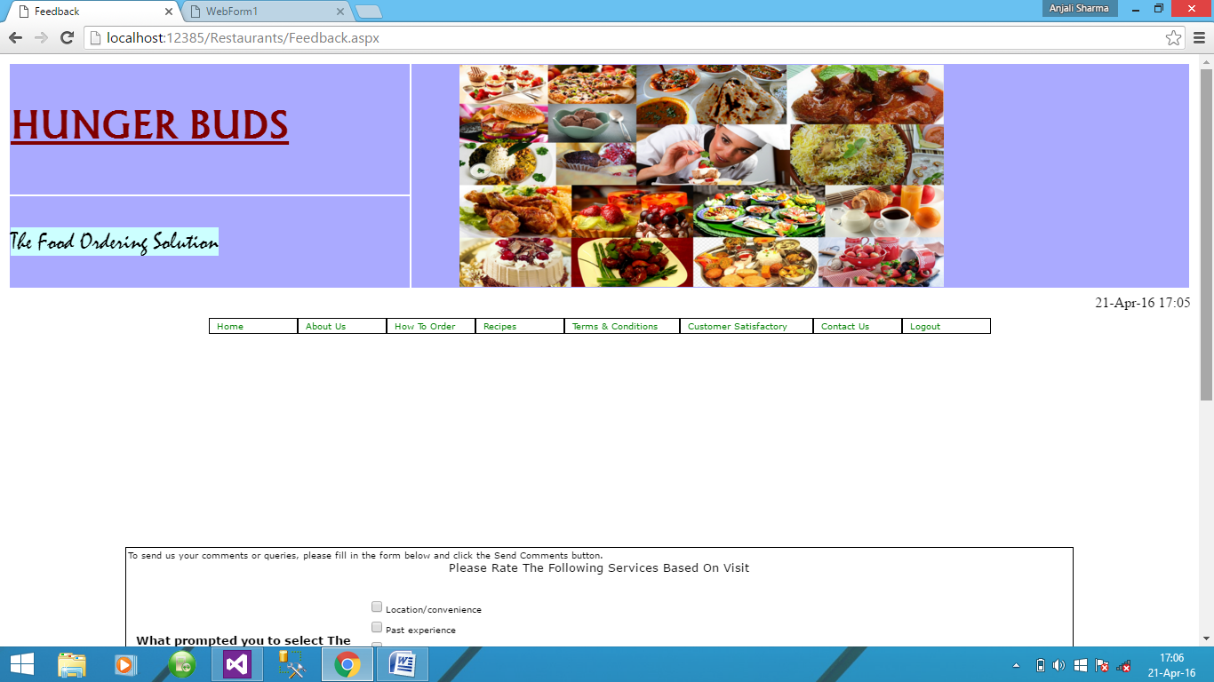

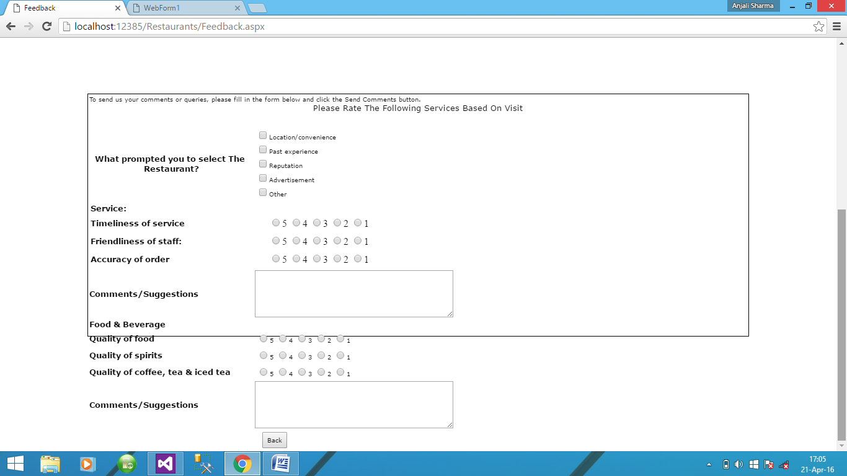

* ***Cart Details***

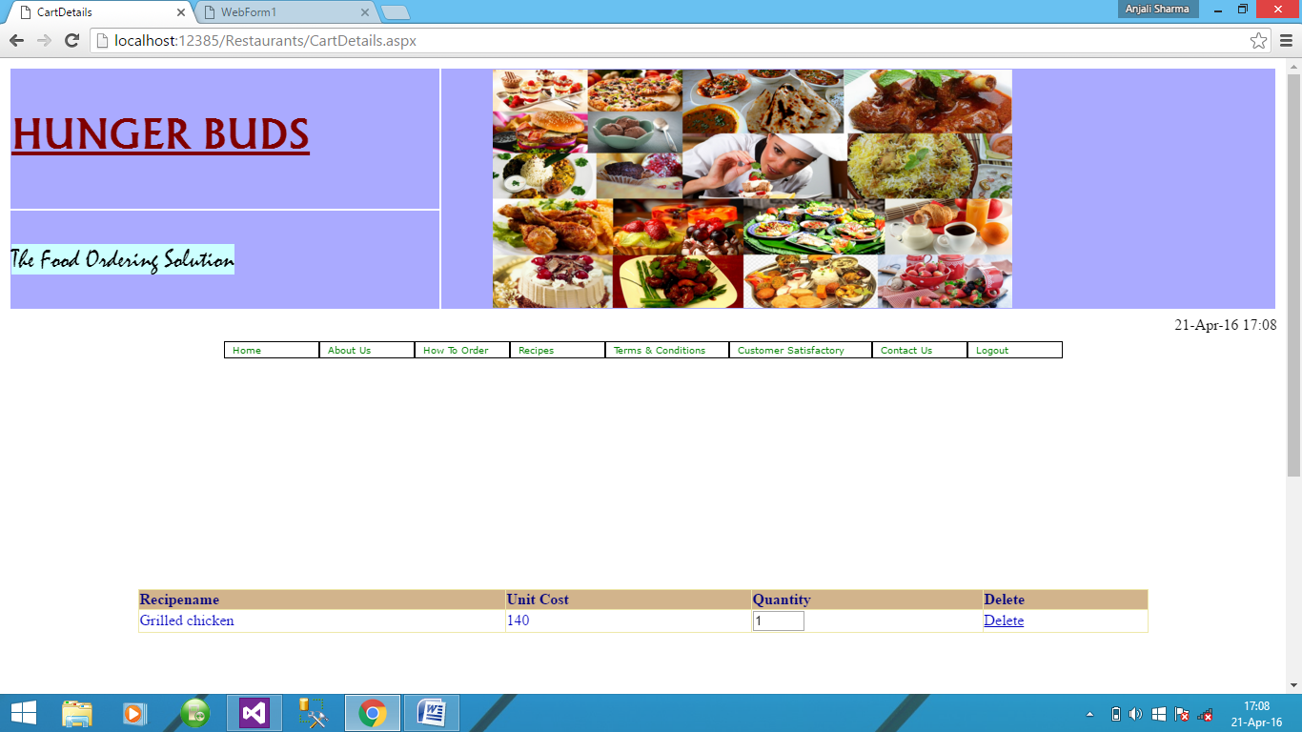

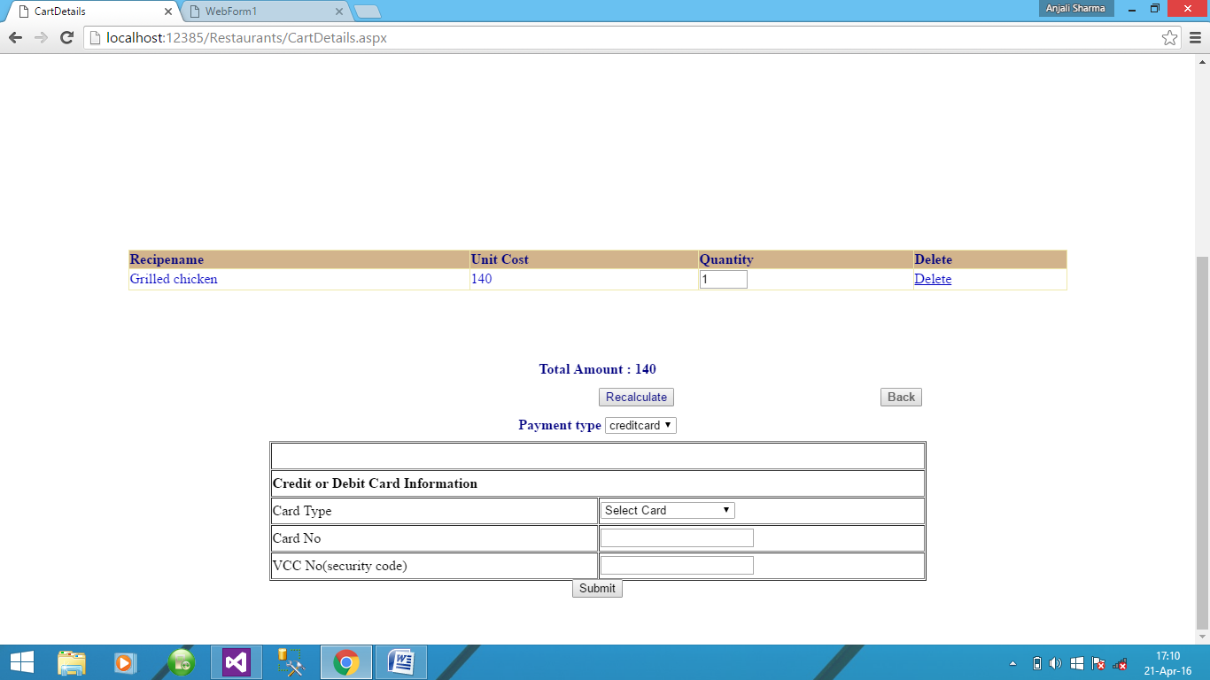

* ***Order Details***

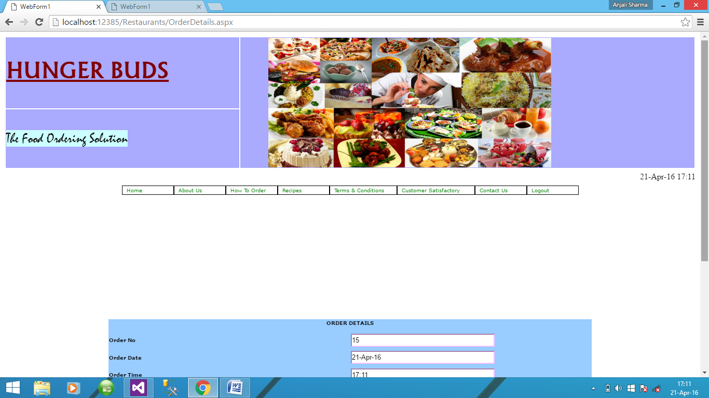

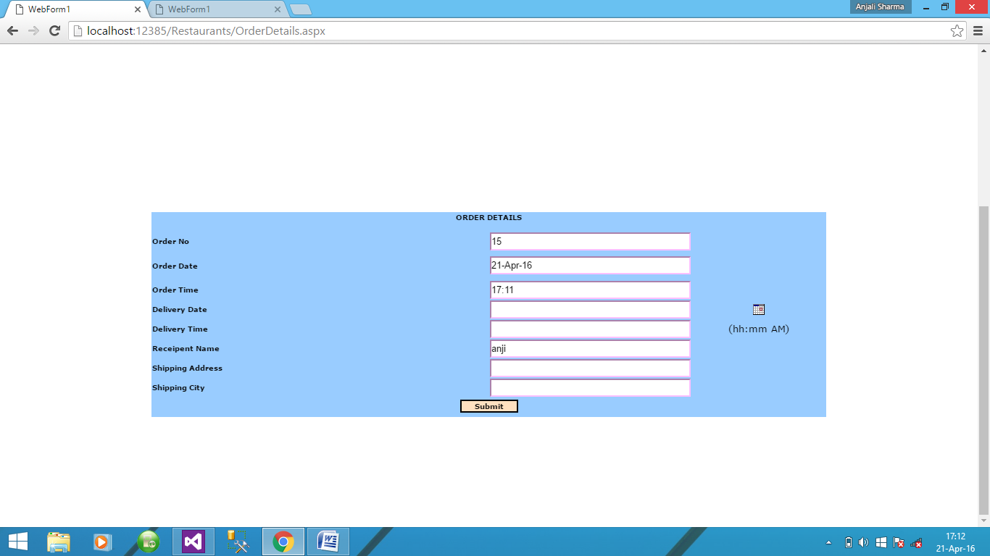

* ***Order Status Details***

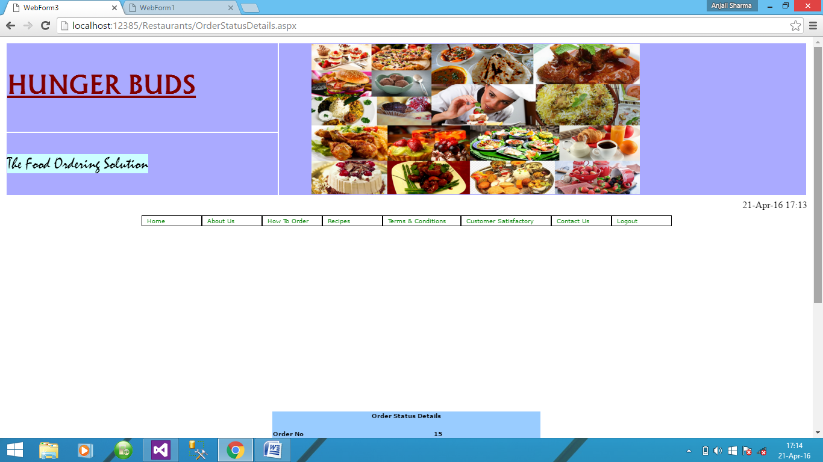

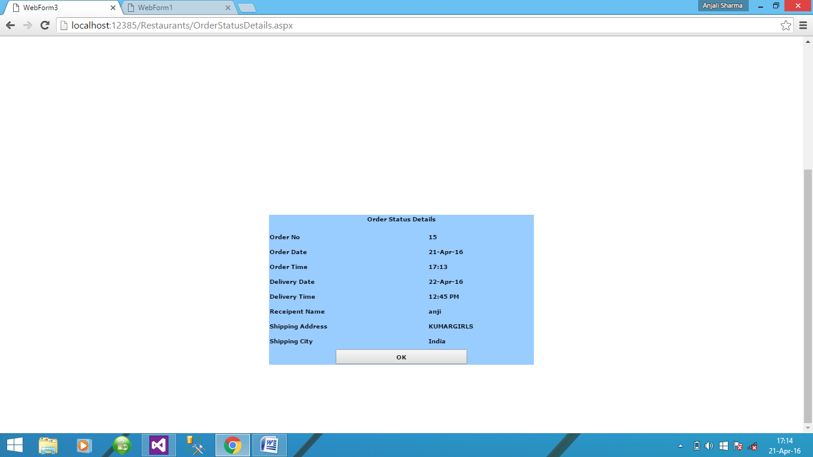

* ***User logs Out***

Admin Login

* ***Home Page***

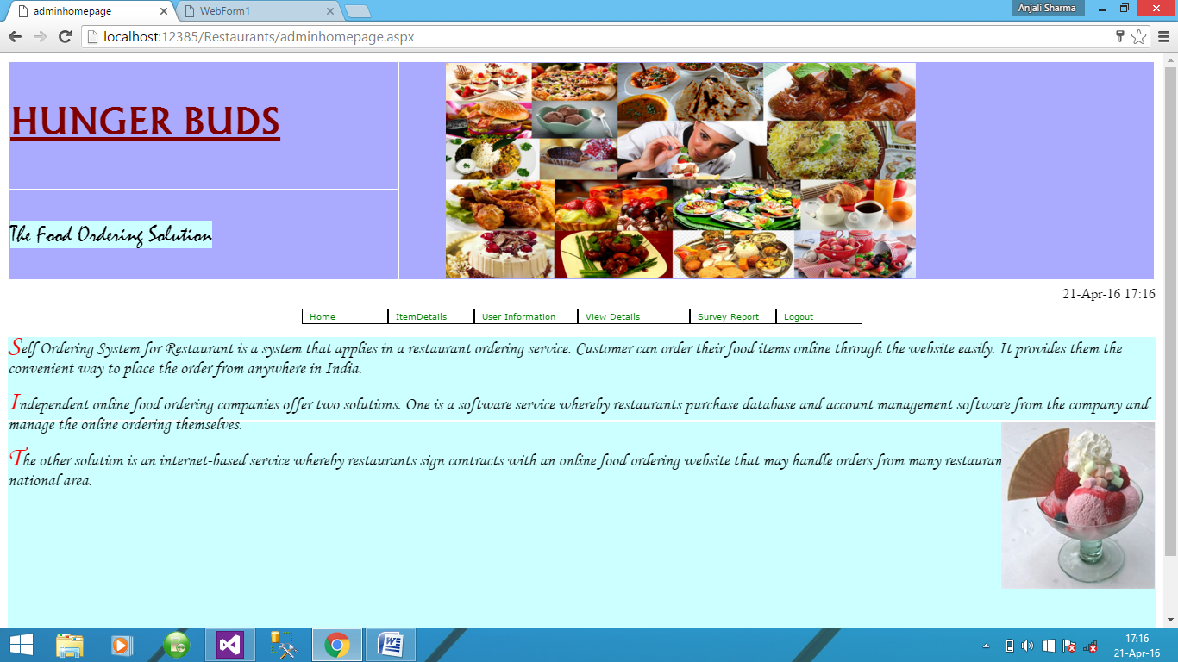

* ***Manage Items***

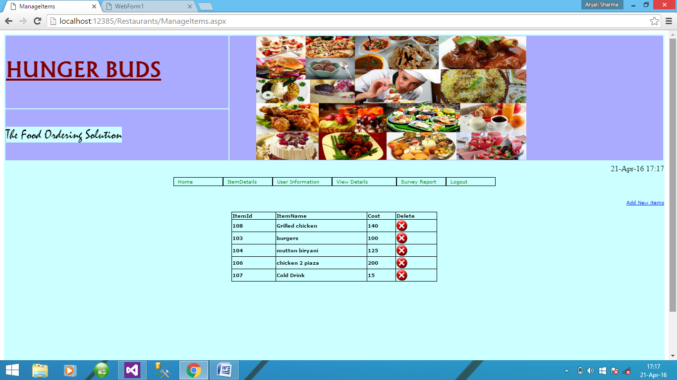

* ***> Adding items***

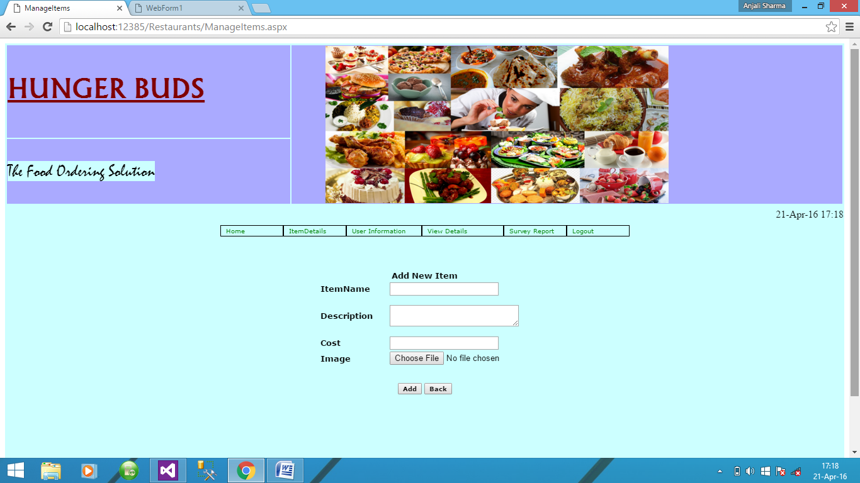

* ***User Information***

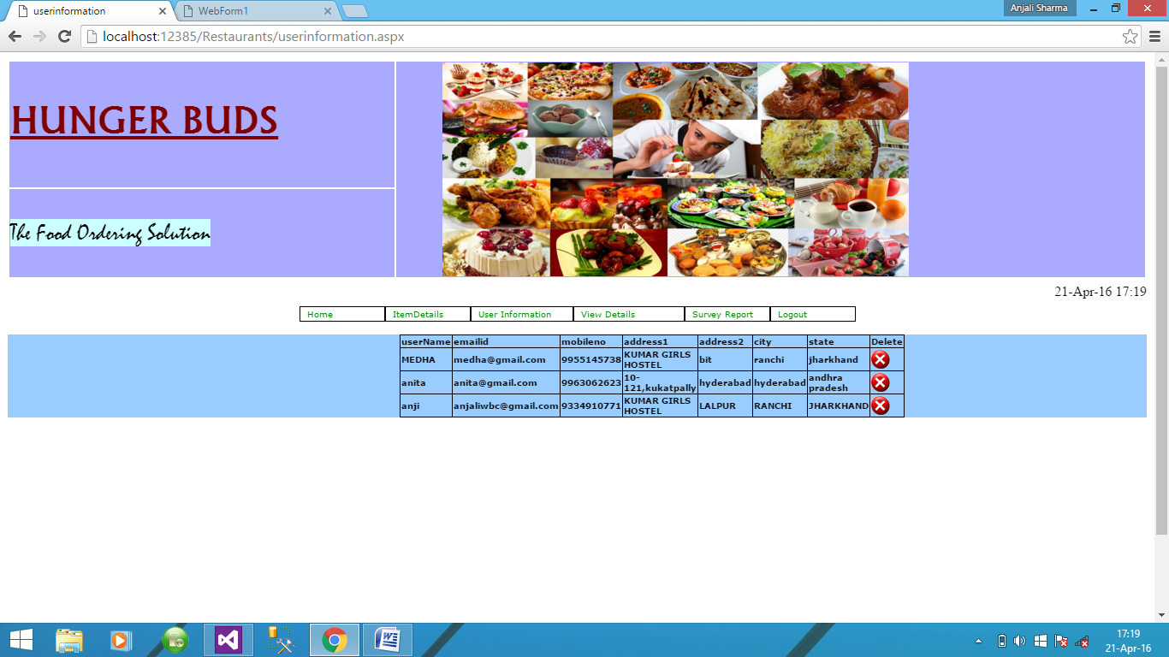

* ***View Orders***

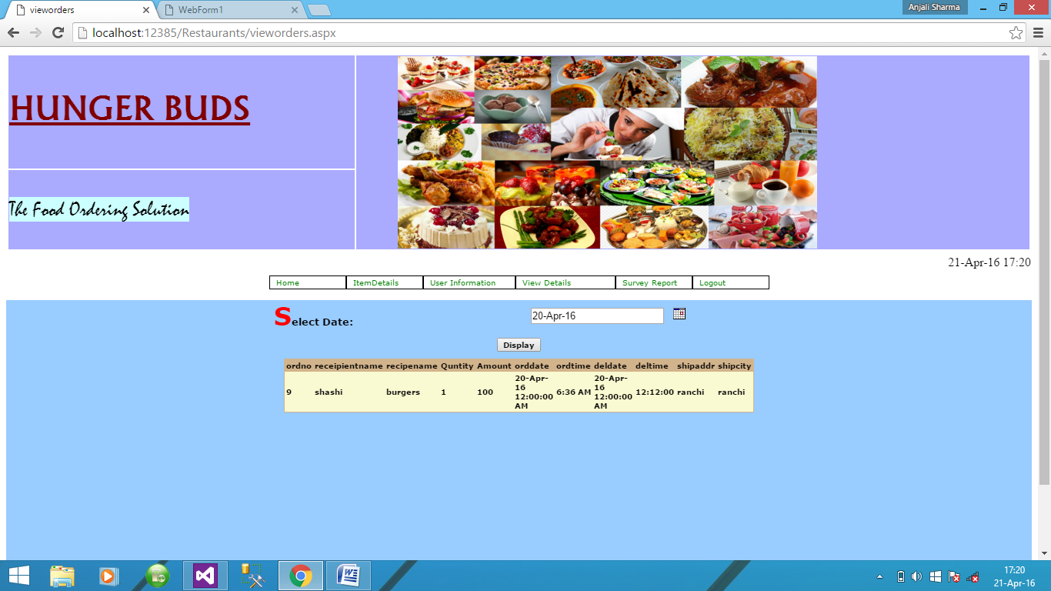

* ***Survey***

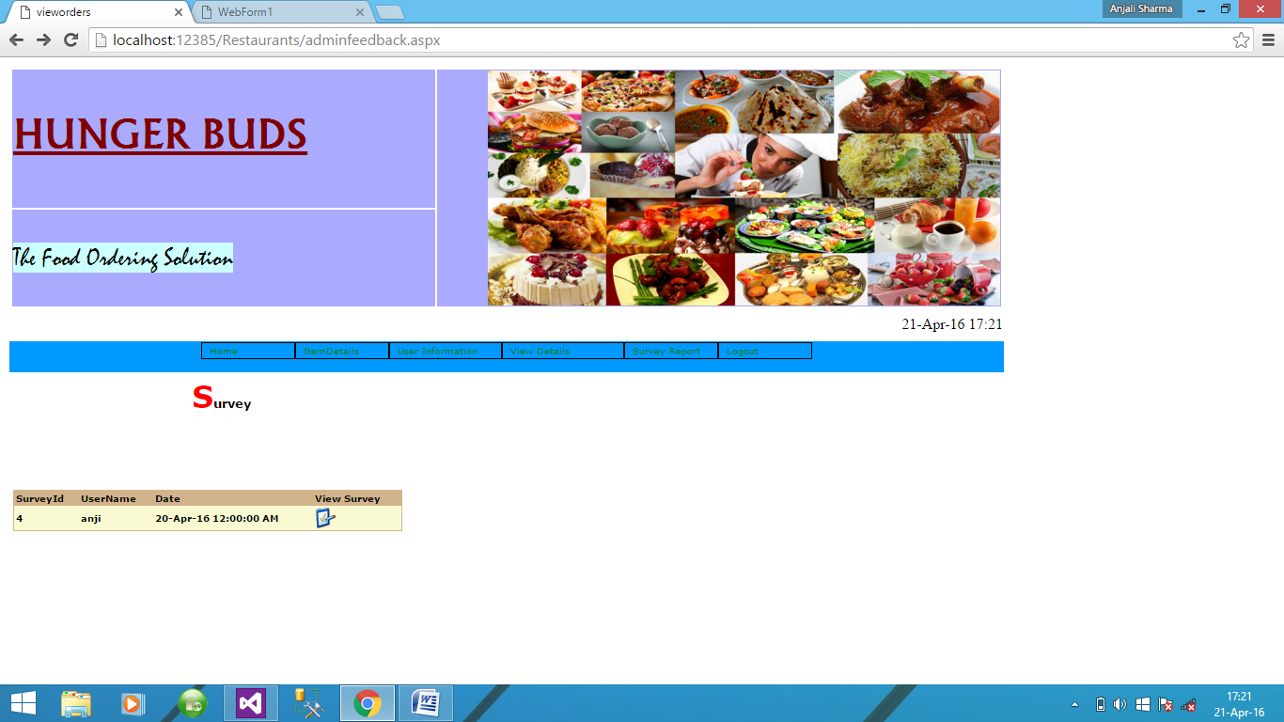

Coding:

* HomePage.aspx

<%@ Register TagPrefix="uc1" TagName="Login" Src="Login.ascx" %>

<%@ Register TagPrefix="uc1" TagName="BackGroundImage" Src="BackGroundImage.ascx" %>

<%@ Register TagPrefix="uc1" TagName="secondmenu" Src="secondmenu.ascx" %>

<%@ Page language="c#" Inherits="OnlineFastFood.WebForm1" CodeFile="HomePage.aspx.cs" %>

<%@ Register TagPrefix="uc1" TagName="TimeDate" Src="TimeDate.ascx" %>

<%@ Register TagPrefix="uc1" TagName="Header" Src="Header.ascx" %>

<%@ Register TagPrefix="uc1" TagName="Fotter" Src="Fotter.ascx" %>

<!DOCTYPE HTML PUBLIC "-//W3C//DTD HTML 4.0 Transitional//EN" >

<HTML>

<HEAD>

<title>WebForm1</title>

<meta content="True" name="vs_snapToGrid">

<meta content="False" name="vs_showGrid">

<meta content="Microsoft Visual Studio .NET 7.1" name="GENERATOR">

<meta content="C#" name="CODE_LANGUAGE">

<meta content="JavaScript" name="vs_defaultClientScript">

<meta content="http://schemas.microsoft.com/intellisense/ie5" name="vs_targetSchema">

<style type="text/css">

.style6

{

width: 270px;

height: 121px;

}

#Table2

{

width: 958px;

}

.style7

{

width: 252px;

}

.style8

{

height: 150px;

}

</style>

</HEAD>

<body >

<form id="Form1" method="post" runat="server">

<asp:panel id="Panel1" style="Z-INDEX: 101; LEFT: 10%; TOP: 0%" runat="server" Height="100%" Width="100%" BorderWidth="1" BorderColor="Black">

<TABLE id="Table1" height="530" cellSpacing="0" cellPadding="1" width="100%">

<TR>

<TD class="style8" >

<uc1:header id="Header1" runat="server"></uc1:header></TD>

</TR>

<TR>

<TD style="HEIGHT: 15px" vAlign="middle" align="right" width="100%" height="31" bgcolor="#CCFFFF">

<uc1:TimeDate id="TimeDate1" runat="server"></uc1:TimeDate></TD>

</TR>

<TR>

<TD vAlign="top" align="center" width="100%" bgcolor="#99CCFF">

<uc1:secondmenu id="Secondmenu1" runat="server"></uc1:secondmenu>

</TD>

</TR>

<TR>

<TD vAlign="top" width="100%" height="150">

<TABLE id="Table2" >

<tr>

<td valign="top" class="style7" bgcolor="#CCFFFF">

<asp:ImageButton ID="ImageButton1" runat="server" Height="305px" ImageUrl="~/Images/fast-food-restaurant.jpg" Width="395px" />

</td>

<TD vAlign="middle" align="right" width="300" class="style6" rowspan="2" bgcolor="#CCFFFF">

<uc1:login id="Login1" runat="server"></uc1:login></TD>

</TR>

<%--<tr><td valign="top">

&nbsp;</td>

<td valign="top" >

&nbsp;</td>--%>

</TABLE>

</TD>

</TR>

<TR>

<TD >

<uc1:Fotter id="Fotter1" runat="server"></uc1:Fotter></TD>

</TR>

</TABLE>

</asp:panel>

</form>

</body>

</HTML>

* Login.aspx

<%@ Control Language="c#" Inherits="OnlineFastFood.Login" CodeFile="Login.ascx.cs" %>

<style type="text/css">

.auto-style1

{

font-family: "Berlin Sans FB";

font-size: small;

}

</style>

<P>

<asp:Panel id="Panel1" runat="server" Width="29%" Height="150px" BorderWidth="1" BorderColor="Gray">

<TABLE id="Table2" style="WIDTH: 310px; height: 162px;" cellSpacing="0" cellPadding="1" border="0" bgcolor="#99CCFF">

<TR>

<TD style="WIDTH: 341px; HEIGHT: 14px" align="center" colSpan="2">

<asp:label id="lblogin" runat="server" ForeColor="Black" Font-Size="X-Small" Font-Underline="True" style="font-size: 15pt; font-family: 'Gill Sans', 'Gill Sans MT', Calibri, 'Trebuchet MS', sans-serif; color: #008000">Customer Login</asp:label></TD>

</TR>

<TR>

<TD style="WIDTH: 341px; HEIGHT: 14px" align="center" colSpan="2"></TD>

</TR>

<TR>

<TD style="WIDTH: 83px; HEIGHT: 19px" align="center">

<asp:label id="lbuserid" Width="68px" runat="server" ForeColor="Black" Font-Size="X-Small" CssClass="auto-style1">User Name</asp:label></TD>

<TD style="WIDTH: 256px; HEIGHT: 19px">

<asp:textbox id="txtuser" Height="20px" Width="120px" runat="server"></asp:textbox></TD>

</TR>

<TR>

<TD style="WIDTH: 83px; HEIGHT: 32px" align="center">

<asp:label id="lbpass" runat="server" ForeColor="Black" Font-Size="X-Small" CssClass="auto-style1">Password</asp:label></TD>

<TD style="WIDTH: 256px; HEIGHT: 32px">

<asp:textbox id="txtpass" Height="20px" Width="120px" runat="server" TextMode="Password"></asp:textbox>

<asp:button id="btlogin" BorderColor="White" Height="24px" Width="69px" runat="server" Font-Size="XX-Small"

BackColor="White" Text="Login" onclick="btlogin_Click" style="font-size: small; font-family: 'Bauhaus 93'"></asp:button></TD>

</TR>

…..

* Login.aspx.cs

namespace OnlineFastFood

{

using System;

using System.Data;

using System.Drawing;

using System.Web;

using System.Web.UI.WebControls;

using System.Web.UI.HtmlControls;

using System.Data.SqlClient;

/// <summary>

/// Summary description for Login.

/// </summary>

public partial class Login : System.Web.UI.UserControl

{

SqlCommand cmd;

SqlConnection con=new SqlConnection(System.Configuration.ConfigurationSettings.AppSettings["ConStr"]);

//OnlineFastFood.KUtilities obj;

protected void Page_Load(object sender, System.EventArgs e)

{

//Obj=new OnlineFood.KUtilities(this);

lblogin.Visible=false;

}

#region Web Form Designer generated code

override protected void OnInit(EventArgs e)

{

//

// CODEGEN: This call is required by the ASP.NET Web Form Designer.

//

InitializeComponent();

base.OnInit(e);

}

/// <summary>

/// Required method for Designer support - do not modify

/// the contents of this method with the code editor.

/// </summary>

private void InitializeComponent()

{

}

#endregion

protected void LinkButton1_Click(object sender, System.EventArgs e)

{

Response.Redirect("NewUser.aspx");

}

protected void btlogin_Click(object sender, System.EventArgs e)

{

string sqlStr ="select * from userdetails where username='"+txtuser.Text+"' and password='"+txtpass.Text+"'";

SqlDataAdapter da=new SqlDataAdapter(sqlStr,con);

DataSet ds = new DataSet();

da.Fill(ds,"Table");

if (ds.Tables[0].Rows.Count.ToString() != "0")

{

Session["UserName"]=txtuser.Text;

Response.Redirect("Recipesdetails.aspx");

}

else

{

cmd = new SqlCommand("Select Count(*) from admin where username='" + txtuser.Text + "' and password ='" + txtpass.Text + "'", con);

cmd.CommandType =CommandType.Text;

con.Open();

int i = Convert.ToInt32(cmd.ExecuteScalar());

if(i==1)

{

Session["UserName"]=txtuser.Text;

Response.Redirect("adminhomepage.aspx");

}

else

{

lbldisplay.Text="Invalid Id/Password";

}

}

//else

// {

// Session["UserName"]=txtuser.Text;

// Response.Redirect("Recipesdetails.aspx");

// }

}

// if (ds.Tables[0].Rows.Count.ToString() == "0")

// {

// Response.Write("<script>alert('User Does Not Exist')</script>");

// if (ds.Tables[0].Rows[0]["password"].ToString() != txtpass.Text)

// {

// //Obj.msgBox("Incorrect Password! Re Enter the Password");

// Response.Write("<script>alert('Incorrect Password! Re Enter the Password')</script>");

// }

//// }

// catch

// {

// lblogin.Visible=true;

// }

protected void lbchangepass_Click(object sender, System.EventArgs e)

{

Response.Redirect("ForgotPassword.aspx");

}

}

}

* NewUser.aspx

<%@ Register TagPrefix="uc1" TagName="Fotter" Src="Fotter.ascx" %>

<%@ Register TagPrefix="uc1" TagName="Header" Src="Header.ascx" %>

<%@ Page language="c#" Inherits="OnlineFastFood.NewUser" CodeFile="NewUser.aspx.cs" %>

<!DOCTYPE HTML PUBLIC "-//W3C//DTD HTML 4.0 Transitional//EN" >

<HTML>

<HEAD>

<title>NewUser</title>

<meta content="Microsoft Visual Studio .NET 7.1" name="GENERATOR">

<meta content="C#" name="CODE_LANGUAGE">

<meta content="JavaScript" name="vs_defaultClientScript">

<meta content="http://schemas.microsoft.com/intellisense/ie5" name="vs_targetSchema">

<script language="javascript">

function validate_fields()

{

//username

if((Form1.txtusername.value=="")||(Form1.txtusername.value.substring(0,1)==" "))

{

alert("Please enter the username ,not more than 15 ");

Form1.txtusername.focus();

return false;

}

var str=Form1.txtusername.value;

for(i=0;i<str.length;i++)

{

ch=str.substring(i,i+1)

if(ch==" ")

{

ch1=str.substring(i+1,i+2)

if(ch1==" ")

{

alert("Double space in Username");

ch2=str.substring(0,i+2);

Form1.txtusername.focus();

Form1.txtusername.value="";

return (false);

}

}

}

var checkOK = "ABCDEFGHIJKLMNOPQRSTUVWXYZabcdefghijklmnopqrstuvwxyz0123456789 ";

var checkStr = Form1.txtusername.value;

var allValid = true;

for (i = 0; i < checkStr.length; i++)

{

ch = checkStr.charAt(i);

for (j = 0; j < checkOK.length; j++)

if (ch == checkOK.charAt(j))

break;

if (j == checkOK.length)

{

allValid = false;

break;

}

}

if (!allValid)

{

alert("Please enter only characters in the field.");

Form1.txtusername.value="";

Form1.txtusername.focus();

return (false);

}

//password

/*if (Form1.txtpassword.value == "")

{

alert("You must enter Password.");

Form1.txtpassword.focus();

return (false);

}

var checkOK = "ABCDEFGHIJKLMNOPQRSTUVWabcdefghijklmnopqrstuvwxyz0123456789`~!@#$%^&*__-=+()':;?/>.<,|";

var checkStr = Form1.txtpassword.value;

var allValid = true;

for (i = 0; i < checkStr.length; i++)

{

ch = checkStr.charAt(i);

for (j = 0; j < checkOK.length; j++)

if (ch == checkOK.charAt(j))

break;

if (j == checkOK.length)

{

allValid = false;

break;

}

}

if (!allValid)

{

alert("Please enter only letter Symbols and numeric characters in the \"Password\" field.");

Form1.txtPassword.focus();

return (false);

}

if (Form1.txtpassword.value.length < 4)

{

alert("Please enter at least 4 characters in the \"Password\" field.");

Form1.txtpassword.focus();

return (false);

}*/

///password

var h=Form1.txtpassword.value

if(h=="" || h.charCodeAt(0)==32)

{

alert("Please Enter Your Password ")

Form1.txtpassword.focus()

Form1.txtpassword.select()

return false;

}

var checkOK = "ABCDEFGHIJKLMNOPQRSTUVWabcdefghijklmnopqrstuvwxyz0123456789`~!@#$%^&*__-=+()':;?/>.<,|";

var checkStr = Form1.txtpassword.value;

var allValid = true;

for (i = 0; i < checkStr.length; i++)

{

ch = checkStr.charAt(i);

for (j = 0; j < checkOK.length; j++)

if (ch == checkOK.charAt(j))

break;

if (j == checkOK.length)

{

allValid = false;

break;

}

}

if (!allValid)

{

alert("Please enter only letter Symbols and numeric characters in the \"Password\" field.");

Form1.txtPassword.focus();

return (false);

}

if (Form1.txtpassword.value.length < 4)

{

alert("Please enter at least 4 characters in the \"Password\" field.");

Form1.txtpassword.focus();

return (false);

}

//retypepassword

var i=Form1.txtretypepassword.value

if(i=="" || i.charCodeAt(0)==32)

{

alert("Please retype ur password ")

Form1.txtretypepassword.focus()

Form1.txtretypepassword.select()

return false;

}

if(h!=i)

{

alert("retype Password not correct")

Form1.txtretypepassword.focus()

Form1.txtretypepassword.select()

return false;

}

//password hint question

if((Form1.dl1pashintq.value=="select"))

{

alert("Please select the password hint question ");

Form1.dl1pashintq.focus();

return false;

}

//hintanswer

if(Form1.txthintanswer.value=="")

{

alert("You must enter hintanswer." );

Form1.txthintanswer.focus();

return false;

}

var str=Form1.txthintanswer.value;

for(i=0;i<str.length;i++)

{

ch=str.substring(i,i+1)

if(ch==" ")

{

alert("single space not allowed");

ch2=str.substring(0,i+1);

Form1.txthintanswer.focus();

return false;

}

}

//Name

if(Form1.txtname.value=="")

{

alert("Please enter the name ,not more than 15." );

Form1.txtname.focus();

return false;

}

var str=Form1.txtname.value;

for(i=0;i<str.length;i++)

{

ch=str.substring(i,i+1)

if(ch==" ")

{

alert("single space not allowed");

ch2=str.substring(0,i+1);

Form1.txtname.focus();

return false;

}

}

var checkOK = "ABCDEFGHIJKLMNOPQRSTUVWXYZabcdefghijklmnopqrstuvwxyz ";

var checkStr = Form1.txtname.value;

var allValid = true;

for (i = 0; i < checkStr.length; i++)

{

ch = checkStr.charAt(i);

for (j = 0; j < checkOK.length; j++)

if (ch == checkOK.charAt(j))

break;

if (j == checkOK.length)

{

allValid = false;

break;

}

}

if (!allValid)

{

alert("Please enter only characters in the field.");

Form1.txtname.value="";

Form1.txtname.focus();

return (false);

}

//Email

if ((Form1.txtemailid.value == "")||(Form1.txtemailid.value=="")||(Form1.txtemailid.value.substring(0,1)==" "))

{

alert("You must enter email.");

Form1.txtemailid.value="";

Form1.txtemailid.focus();

return (false);

}

if (Form1.txtemailid.value.length<10)

{

alert("You must enter 10 charecters in email.");

Form1.txtemailid.value="";

Form1.txtemailid.focus();

return (false);

}

var checkTLD=1;

var knownDomsPat=/^(com|net|org|edu|int|mil|gov|arpa|biz|aero|name|coop|info|pro|museum|in|COM|NET|ORG|EDU|INT|MIL|GOV|ARPA|BIZ|AERO|NAME|COOP|INFO|PRO|MUSEUM|IN)$/;

var emailPat=/^(.+)@(.+)$/;

var specialChars="\\(\\)><@,;:\\\\\\\"\\.\\[\\]";

var validChars="\[^\\s" + specialChars + "\]";

var quotedUser="(\"[^\"]*\")";

var ipDomainPat=/^\[(\d{1,3})\.(\d{1,3})\.(\d{1,3})\.(\d{1,3})\]$/;

var atom=validChars + '+';

var word="(" + atom + "|" + quotedUser + ")";

var userPat=new RegExp("^" + word + "(\\." + word + ")*$");

var domainPat=new RegExp("^" + atom + "(\\." + atom +")*$");

var matchArray=document.Form1.txtemailid.value.match(emailPat);

if (matchArray==null)

{

alert("Email address seems incorrect (check @ and .'s)");

Form1.txtemailid.focus();

return false;

}

var user=matchArray[1];

var domain=matchArray[2];

for (i=0; i<user.length; i++) {

if (user.charCodeAt(i)>127) {

alert("Ths username contains invalid characters.");

Form1.txtemailid.focus();

return false;

}

}

for (i=0; i<domain.length; i++)

{

if (domain.charCodeAt(i)>127)

{

alert("Ths domain name contains invalid characters.");

Form1.txtemailid.focus();

return false;

}

}

if (user.match(userPat)==null)

{

alert("The username doesn't seem to be valid.");

Form1.txtemailid.focus();

return false;

}

var IPArray=domain.match(ipDomainPat);

if (IPArray!=null)

{

for (var i=1;i<=4;i++)

{

if (IPArray[i]>255)

{

alert("Destination IP address is invalid!");

Form1.Email.focus();

return false;

}

}

return true;

}

var atomPat=new RegExp("^" + atom + "$");

var domArr=domain.split(".");

var len=domArr.length;

for (i=0;i<len;i++)

{

if (domArr[i].search(atomPat)==-1)

{

alert("The domain name does not seem to be valid.");

Form1.txtemailid.focus();

return false;

}

}

if (checkTLD && domArr[domArr.length-1].length!=2 &&

domArr[domArr.length-1].search(knownDomsPat)==-1)

{

alert("The address must end in a well-known domain or two letter " + "country.");

Form1.txtemailid.focus();

return false;

}

if (len<2)

{

alert("This address is missing a hostname!");

Form1.txtemailid.focus();

return false;

}

//Confirm Email

if(Form1.txtconfemailid.value=="")

{

alert("Please enter the confemailid" );

Form1.txtconfemailid.focus();

return false;

}

//secondary Email id

if(Form1.txtsecemailid.value!="")

{

if ((Form1.txtsecemailid.value == "")||(Form1.txtsecemailid.value=="")||(Form1.txtsecemailid.value.substring(0,1)==" "))

{

alert("You must enter email.");

Form1.txtsecemailid.value="";

Form1.txtsecemailid.focus();

return (false);

}

if (Form1.txtsecemailid.value.length<10)

{

alert("field should not be lessthan 10.");

Form1.txtsecemailid.value="";

Form1.txtsecemailid.focus();

return (false);

}

var checkTLD=1;

var knownDomsPat=/^(com|net|org|edu|int|mil|gov|arpa|biz|aero|name|coop|info|pro|museum|in|COM|NET|ORG|EDU|INT|MIL|GOV|ARPA|BIZ|AERO|NAME|COOP|INFO|PRO|MUSEUM|IN)$/;

var emailPat=/^(.+)@(.+)$/;

var specialChars="\\(\\)><@,;:\\\\\\\"\\.\\[\\]";

var validChars="\[^\\s" + specialChars + "\]";

var quotedUser="(\"[^\"]*\")";

var ipDomainPat=/^\[(\d{1,3})\.(\d{1,3})\.(\d{1,3})\.(\d{1,3})\]$/;

var atom=validChars + '+';

var word="(" + atom + "|" + quotedUser + ")";

var userPat=new RegExp("^" + word + "(\\." + word + ")*$");

var domainPat=new RegExp("^" + atom + "(\\." + atom +")*$");

var matchArray=document.Form1.txtsecemailid.value.match(emailPat);

if (matchArray==null)

{

alert("Email address seems incorrect (check @ and .'s)");

Form1.txtsecemailid.focus();

return false;

}

var user=matchArray[1];

var domain=matchArray[2];

for (i=0; i<user.length; i++) {

if (user.charCodeAt(i)>127) {

alert("Ths username contains invalid characters.");

Form1.txtsecemailid.focus();

return false;

}

}

for (i=0; i<domain.length; i++)

{

if (domain.charCodeAt(i)>127)

{

alert("Ths domain name contains invalid characters.");

Form1.txtsecemailid.focus();

return false;

}

}

if (user.match(userPat)==null)

{

alert("The username doesn't seem to be valid.");

Form1.txtemailid.focus();

return false;

}

var IPArray=domain.match(ipDomainPat);

if (IPArray!=null)

{

for (var i=1;i<=4;i++)

{

if (IPArray[i]>255)

{

alert("Destination IP address is invalid!");

Form1.txtsecemailid.focus();

return false;

}

}

return true;

}

var atomPat=new RegExp("^" + atom + "$");

var domArr=domain.split(".");

var len=domArr.length;

for (i=0;i<len;i++)

{

if (domArr[i].search(atomPat)==-1)

{

alert("The domain name does not seem to be valid.");

Form1.txtsecemailid.focus();

return false;

}

}

if (checkTLD && domArr[domArr.length-1].length!=2 &&

domArr[domArr.length-1].search(knownDomsPat)==-1)

{

alert("The address must end in a well-known domain or two letter " + "country.");

Form1.txtsecemailid.focus();

return false;

}

if (len<2)

{

alert("This address is missing a hostname!");

Form1.txtsecemailid.focus();

return false;

}

}

//ic no

if ((Form1.txt_icno.value == "")||(Form1.txt_icno.value=="")||(Form1.txt_icno.value.substring(0,1)==" "))

{

alert("You must enter IC Number.");

Form1.txt_icno.value="";

Form1.txt_icno.focus();

return (false);

}

var checkOK = "0123456789";

var checkStr = Form1.txt_icno.value;

var allValid = true;

for (i = 0; i < checkStr.length; i++)

{

ch = checkStr.charAt(i);

for (j = 0; j < checkOK.length; j++)

if (ch == checkOK.charAt(j))

break;

if (j == checkOK.length)

{

allValid = false;

break;

}

}

if (!allValid)

{

alert("Please enter only numbers in the IC Number.");

Form1.txt_icno.value="";

Form1.txt_icno.focus();

return (false);

}

var checkOK1= "0";

var checkStr1 = Form1.txt_icno.value;

var allValid = true;

for (i = 0; i < checkStr1.length; i++)

{

ch = checkStr1.charAt(i);

for (j = 0; j < checkOK1.length; j++)

if (ch == checkOK1.charAt(j))

break;

if (j == checkOK1.length)

{

allValid = false;

break;

}

}

if (allValid)

{

alert("Please enter only numbers in the \"IC Number\" field.");

Form1.txt_icno.value="";

Form1.txt_icno.focus();

return (false);

}

//icno

//Phone

if ((Form1.txtphno.value == "")||(Form1.txtphno.value=="")||(Form1.txtphno.value.substring(0,1)==" "))

{

alert("You must enter phone.");

Form1.txtphno.value="";

Form1.txtphno.focus();

return (false);

}

if((Form1.txtphno.value.charAt(0)!="0"))

{

alert("enter the first digit is 0 .");

Form1.txtphno.value="";

Form1.txtphno.focus();

return (false);

}

if (Form1.txtphno.value.length<10)

{

alert("You must enter 10 digits in phoneno.");

Form1.txtphno.value="";

Form1.txtphno.focus();

return (false);

}

var checkOK = "0123456789";

var checkStr = Form1.txtphno.value;

var allValid = true;

for (i = 0; i < checkStr.length; i++)

{

ch = checkStr.charAt(i);

for (j = 0; j < checkOK.length; j++)

if (ch == checkOK.charAt(j))

break;

if (j == checkOK.length)

{

allValid = false;

break;

}

}

if (!allValid)

{

alert("Please enter only numbers in the \"phone\" field.");

Form1.txtphno.value="";

Form1.txtphno.focus();

return (false);

}

var checkOK1= "0";

var checkStr1 = Form1.txtphno.value;

var allValid = true;

for (i = 0; i < checkStr1.length; i++)

{

ch = checkStr1.charAt(i);

for (j = 0; j < checkOK1.length; j++)

if (ch == checkOK1.charAt(j))

break;

if (j == checkOK1.length)

{

allValid = false;

break;

}

}

if (allValid)

{

alert("Please dont enter zeros in the \"phone\" field.");

Form1.txtphno.value="";

Form1.txtphno.focus();

return (false);

}

//mobile no

var checkOK = "0123456789";

var checkStr = Form1.txtmobileno.value;

var allValid = true;

for (i = 0; i < checkStr.length; i++)

{

ch = checkStr.charAt(i);

for (j = 0; j < checkOK.length; j++)

if (ch == checkOK.charAt(j))

break;

if (j == checkOK.length)

{

allValid = false;

break;

}

}

if (!allValid)

{

alert("Please enter only numbers in the \"moblie\" field.");

Form1.txtmobileno.value="";

Form1.txtmobileno.focus();

return (false);

}

var checkOK1= "0";

var checkStr1 = Form1.txtmobileno.value;

var allValid = true;

for (i = 0; i < checkStr1.length; i++)

{

ch = checkStr1.charAt(i);

for (j = 0; j < checkOK1.length; j++)

if (ch == checkOK1.charAt(j))

break;

if (j == checkOK1.length)

{

allValid = false;

break;

}

}

if(Form1.txtmobileno.value!="")

{

if((Form1.txtmobileno==0) ||(Form1.txtmobileno.value==00)||(Form1.txtmobileno.value==000) ||(Form1.txtmobileno.value==0000) ||(Form1.txtmobileno.value==00000) || (Form1.txtmobileno.value==000000) ||(Form1.txtmobileno.value==00000000) || (Form1.txtmobileno.value==000000000) || (Form1.txtmobileno.value==0000000000))

{

alert("Please enter mobileno field correctly.");

Form1.txtmobileno.focus();

Form1.txtmobileno.value="";

return(false);

}

}

//Fax no

var checkOK = "0123456789";

var checkStr = Form1.txtfaxno.value;

var allValid = true;

for (i = 0; i < checkStr.length; i++)

{

ch = checkStr.charAt(i);

for (j = 0; j < checkOK.length; j++)

if (ch == checkOK.charAt(j))

break;

if (j == checkOK.length)

{

allValid = false;

break;

}

}

var str=Form1.txtfaxno.value;

for(i=0;i<str.length;i++)

{

ch=str.substring(i,i+1)

if(ch==" ")

{

ch1=str.substring(i+1,i+2)

if(ch1==" ")

{

alert("Double space in Fax field");

ch2=str.substring(0,i+2);

Form1.txtfaxno.focus();

Form1.txtfaxno.value="";

return (false);

}

}

}

if (!allValid)

{

alert("Please enter only numeric characters in Fax no field.");

Form1.txtfaxno.focus();

Form1.txtfaxno.value="";

return (false);

}

if (Form1.txtfaxno.value.length > 10)

{

alert("The Fax no field digits should not exceed 10");

Form1.txtfaxno.focus();

Form1.txtfaxno.value="";

return(false);

}

if(Form1.txtfaxno.value!="")

{

if((Form1.txtfaxno==0) ||(Form1.txtfaxno.value==00)||(Form1.txtfaxno.value==000) ||(Form1.txtfaxno.value==0000) ||(Form1.txtfaxno.value==00000) || (Form1.txtfaxno.value==000000) ||(Form1.txtfaxno.value==00000000) || (Form1.txtfaxno.value==000000000) || (Form1.txtfaxno.value==0000000000))

{

alert("Please enter Faxno field correctly.");

Form1.txtfaxno.focus();

Form1.txtfaxno.value="";

return(false);

}

}

//Address1

if ((Form1.txtaddr1.value == "")||(Form1.txtaddr1.value=="")||(Form1.txtaddr1.value.substring(0,1)==" "))

{

alert("You must enter Adress1.");

Form1.txtaddr1.value="";

Form1.txtaddr1.focus();

return (false);

}

if (Form1.txtaddr1.value.length<10)

{

alert("You must enter 10 charecters in Adress1.");

Form1.txtaddr1.value="";

Form1.txtaddr1.focus();

return (false);

}

var str=Form1.txtaddr1.value;

for(i=0;i<str.length;i++)

{

ch=str.substring(i,i+1)

if(ch==" ")

{

ch1=str.substring(i+1,i+2)

if(ch1==" ")

{

alert("Please don't enter Double space in Adress1");

ch2=str.substring(0,i+2);

Form1.txtaddr1.focus();

Form1.txtaddr1.value="";

return (false);

}

}

}

var checkOK = "ABCDEFGHIJKLMNOPQRSTUVWXYZabcdefghijklmnopqrstuvwxyz0123456789-./#,(): ";

var checkStr = Form1.txtaddr1.value;

var allValid = true;

for (i = 0; i < checkStr.length; i++)

{

ch = checkStr.charAt(i);

for (j = 0; j < checkOK.length; j++)

if (ch == checkOK.charAt(j))

break;

if (j == checkOK.length)

{

allValid = false;

break;

}

}

if (!allValid)

{

alert("Please enter only characters in the \"Adress1\" field.");

Form1.txtaddr1.value="";

Form1.txtaddr1.focus();

return (false);

}

//Address2

var str=Form1.txtaddr2.value;

for(i=0;i<str.length;i++)

{

ch=str.substring(i,i+1)

if(ch==" ")

{

ch1=str.substring(i+1,i+2)

if(ch1==" ")

{

alert("Please don't enter Double space in Adress2");

ch2=str.substring(0,i+2);

Form1.txtaddr2.focus();

Form1.txtaddr2.value="";

return (false);

}

}

}

if(Form1.txtaddr2.value!="")

{

if ((Form1.txtaddr2.value == "")||(Form1.txtaddr2.value=="")||(Form1.txtaddr2.value.substring(0,1)==" "))

{

alert(" enter adrees2 field correctly ");

Form1.txtaddr2.value="";

Form1.txtaddr2.focus();

return (false);

}

}

// city

if ((Form1.txtcity.value == "")||(Form1.txtcity.value=="")||(Form1.txtcity.value.substring(0,1)==" "))

{

alert("You must enter city.");

Form1.txtcity.value="";

Form1.txtcity.focus();

return (false);

}

if (Form1.txtcity.value.length<3)

{

alert("You must enter 3 characters in city.");

Form1.txtcity.value="";

Form1.txtcity.focus();

return (false);

}

var checkOK = "ABCDEFGHIJKLMNOPQRSTUVWXYZabcdefghijklmnopqrstuvwxyz ";

var checkStr = Form1.txtcity.value;

var allValid = true;

for (i = 0; i < checkStr.length; i++)

{

ch = checkStr.charAt(i);

for (j = 0; j < checkOK.length; j++)

if (ch == checkOK.charAt(j))

break;

if (j == checkOK.length)

{

allValid = false;

break;

}

}

if (!allValid)

{

alert("Please enter only characters in the \"city \" field.");

Form1.txtcity.value="";

Form1.txtcity.focus();

return (false);

}

var str=Form1.txtcity.value;

for(i=0;i<str.length;i++)

{

ch=str.substring(i,i+1)

if(ch==" ")

{

ch1=str.substring(i+1,i+2)

if(ch1==" ")

{

alert("Please don't enter Double space and city field");

ch2=str.substring(0,i+2);

Form1.txtcity.focus();

Form1.txtcity.value="";

return (false);

}

}

}

var str=Form1.txtcity.value;

for(i=0;i<str.length;i++)

{

ch=str.substring(i,i+1)

if(ch==" ")

{

ch1=str.substring(i+0,i+1)

if(ch1==" ")

{

alert("Please don't enter single space and city field");

ch2=str.substring(0,i+1);

Form1.txtcity.focus();

Form1.txtcity.value="";

return (false);

}

}

}

//state

if ((Form1.txtstate.value == "")||(Form1.txtstate.value=="")||(Form1.txtstate.value.substring(0,1)==" "))

{

alert("You must enter state.");

Form1.txtstate.value="";

Form1.txtstate.focus();

return (false);

}

if (Form1.txtstate.value.length<2)

{

alert("You must enter 3 characters in state.");

Form1.txtstate.value="";

Form1.txtstate.focus();

return (false);

}

var checkOK = "ABCDEFGHIJKLMNOPQRSTUVWXYZabcdefghijklmnopqrstuvwxyz ";

var checkStr = Form1.txtstate.value;

var allValid = true;

for (i = 0; i < checkStr.length; i++)

{

ch = checkStr.charAt(i);

for (j = 0; j < checkOK.length; j++)

if (ch == checkOK.charAt(j))

break;

if (j == checkOK.length)

{

allValid = false;

break;

}

}

if (!allValid)

{

alert("Please enter only characters in the \"state \" field.");

Form1.txtstate.value="";

Form1.txtstate.focus();

return (false);

}

var str=Form1.txtstate.value;

for(i=0;i<str.length;i++)

{

ch=str.substring(i,i+1)

if(ch==" ")

{

ch1=str.substring(i+1,i+2)

if(ch1==" ")

{

alert("pls dont give Double space");

ch2=str.substring(0,i+2);

Form1.txtstate.focus();

Form1.txtstate.value="";

return (false);

}

}

}

//Zipcode

if ((Form1.txtzipcode.value == "")||(Form1.txtzipcode.value=="")||(Form1.txtzipcode.value.substring(0,1)==" "))

{

alert("You must enter zip.");

Form1.txtzipcode.value="";

Form1.txtzipcode.focus();

return (false);

}

if (Form1.txtzipcode.value.length<6)

{

alert("You must enter6 digits in zip.");

Form1.txtzipcode.value="";

Form1.txtzipcode.focus();

return (false);

}

var checkOK = "0123456789";

var checkStr = Form1.txtzipcode.value;

var allValid = true;

for (i = 0; i < checkStr.length; i++)

{

ch = checkStr.charAt(i);

for (j = 0; j < checkOK.length; j++)

if (ch == checkOK.charAt(j))

break;

if (j == checkOK.length)

{

allValid = false;

break;

}

}

if (!allValid)

{

alert("Please enter only Numbers in the \"zip \" field.");

Form1.txtzipcode.value="";

Form1.txtzipcode.focus();

return (false);

}

var checkOK3 = "0";

var checkStr3 = Form1.txtzipcode.value;

var allValid = true;

for (i = 0; i < checkStr3.length; i++)

{

ch = checkStr3.charAt(i);

for (j = 0; j < checkOK3.length; j++)

if (ch == checkOK3.charAt(j))

break;

if (j == checkOK3.length)

{

allValid = false;

break;

}

}

if (allValid)

{

alert("Please dont enter zeros in the \"Zip\" field.");

Form1.txtzipcode.value="";

Form1.txtzipcode.focus();

return (false);

}

//country

if(Form1.txtcountry.value=="")

{

alert("plz Enter country");

Form1.txtcountry.focus();

return false;

}

}

</script>

</HEAD>

<body>

<form id="Form1" method="post" runat="server">

<asp:Panel id="Panel1" runat="server" >

<TABLE >

<TR>

<TD >

<uc1:header id="Header1" runat="server"></uc1:header></TD>

</TR>

<TR>

<TD vAlign="middle" align="left" width="100%" colSpan="2" height="30">

<asp:Label id="Label26" runat="server" Visible="False">Label</asp:Label></TD>

</TR>

<TR>

<TD vAlign="top" align="center" width="100%" height="420">

<TABLE id="Table2" height="400" cellSpacing="0" cellPadding="0"

width="80%" border="1" bgcolor="#99CCFF">

<TR>

<TD vAlign="middle" align="center" width="100%" colSpan="2" height="16">

<asp:label id="Label19" runat="server" Font-Bold="True">New Customers</asp:label></TD>

</TR>

<TR>

<TD vAlign="middle" align="center" width="100%" colSpan="2" height="16">

<asp:label id="Label16" runat="server" Width="176px" Font-Bold="True">Create New Account</asp:label></TD>

</TR>

<TR>

<TD vAlign="middle" align="left" width="100%" colSpan="2" height="16">

<asp:label id="Label21" runat="server" Width="366px" Font-Size="X-Small" Font-Names="Verdana">Marked with

<font color="#CC3300">

*</font> is mandatory. You cannot leave them blank </asp:label></TD>

</TR>

<TR>

<TD style="HEIGHT: 21px" vAlign="top" align="left" width="40%" height="21">

<asp:label id="Label1" runat="server" Font-Size="X-Small" Font-Names="Verdana"><font color="#CC3300">

*</font>User Name</asp:label></TD>

<TD style="HEIGHT: 21px" vAlign="top" align="left" width="60%" height="21">

<asp:textbox id="txtusername" runat="server" Height="24px" Width="75%" Font-Size="X-Small"></asp:textbox></TD>

</TR>

<TR>

<TD vAlign="top" align="left" width="40%" height="16">

<asp:label id="Label2" runat="server" Font-Size="X-Small" Font-Names="Verdana"><font color="#CC3300">

*</font>Password</asp:label></TD>

<TD vAlign="top" align="left" width="60%" height="16">

<asp:textbox id="txtpassword" runat="server" Height="24px" Width="75%" Font-Size="X-Small" TextMode="Password" ontextchanged="txtpassword_TextChanged"></asp:textbox></TD>

</TR>

<TR>

<TD vAlign="top" align="left" width="40%" height="16">

<asp:label id="Label3" runat="server" Font-Size="X-Small" Font-Names="Verdana"><font color="#CC3300">

*</font>Retype Password</asp:label></TD>

<TD vAlign="top" align="left" width="60%" height="16">

<asp:textbox id="txtretypepassword" runat="server" Height="24px" Width="75%" Font-Size="X-Small"

TextMode="Password"></asp:textbox></TD>

</TR>

<TR>

<TD vAlign="top" align="left" width="40%" colSpan="2" height="16">

<asp:label id="Label22" runat="server" Width="597px" Font-Size="X-Small" Font-Names="Verdana">In case you forgot your password & want to recall we use following question to verify your identity. </asp:label></TD>

</TR>

<TR>

<TD style="HEIGHT: 65px" vAlign="top" align="left" width="40%" height="65">

<asp:label id="Label4" runat="server" Font-Size="X-Small" Font-Names="Verdana"><font color="#CC3300">

*</font>Password Hint Question</asp:label></TD>

<TD style="HEIGHT: 65px" vAlign="top" align="left" width="60%" height="65">

<asp:dropdownlist id="dl1pashintq" runat="server" Height="24px" Width="75%">

<asp:ListItem Value="select">select</asp:ListItem>

<asp:ListItem Value="what is your pet name">what is your pet name</asp:ListItem>

<asp:ListItem Value="what is your favourite colour">what is your favourite colour</asp:ListItem>

<asp:ListItem Value="what is your first school name">what is your first school name</asp:ListItem>

<asp:ListItem Value="who is your favoutite hero">who is your favoutite hero</asp:ListItem>

</asp:dropdownlist></TD>

</TR>

<TR>

<TD vAlign="top" align="left" width="40%" height="16">

<asp:label id="Label5" runat="server" Font-Size="X-Small" Font-Names="Verdana"><font color="#CC3300">

*</font>Hint Answer</asp:label></TD>

<TD vAlign="top" align="left" width="60%" height="16">

<asp:textbox id="txthintanswer" runat="server" Height="24px" Width="75%" Font-Size="X-Small"

TextMode="Password"></asp:textbox></TD>

</TR>

<TR>

<TD vAlign="top" align="left" width="40%" colSpan="2" height="16">

<asp:label id="Label6" runat="server">Enter Your Personal Information</asp:label></TD>

</TR>

<TR>

<TD vAlign="top" align="left" width="40%" height="16">

<asp:label id="Label7" runat="server" Font-Size="X-Small" Font-Names="Verdana"><font color="#CC3300">

*</font>Name</asp:label></TD>

<TD vAlign="top" align="left" width="60%" height="16">

<asp:textbox id="txtname" runat="server" Height="24px" Width="75%" Font-Size="X-Small"></asp:textbox></TD>

</TR>

<TR>

<TD vAlign="top" align="left" width="40%" height="16">

<asp:label id="Label8" runat="server" Font-Size="X-Small" Font-Names="Verdana"><font color="#CC3300">

*</font>Email ID</asp:label></TD>

<TD vAlign="top" align="left" width="60%" height="16">

<asp:textbox id="txtemailid" runat="server" Height="24px" Width="75%" Font-Size="X-Small"></asp:textbox></TD>

</TR>

<TR>

<TD vAlign="top" align="left" width="40%" colSpan="2" height="16">

<asp:label id="Label9" runat="server" Font-Size="X-Small" Font-Names="Verdana"> (Enter your Primary Email-ID which is used regularly)</asp:label></TD>

</TR>

<TR>

<TD vAlign="top" align="left" width="40%" height="16">

<asp:label id="Label10" runat="server" Font-Size="X-Small" Font-Names="Verdana"><font color="#CC3300">

*</font>Confirm Email ID</asp:label></TD>

<TD vAlign="top" align="left" width="60%" height="16">

<asp:textbox id="txtconfemailid" runat="server" Height="24px" Width="75%" Font-Size="X-Small"></asp:textbox></TD>

</TR>

<TR>

<TD style="HEIGHT: 30px" vAlign="top" align="left" width="40%" height="30">

<asp:label id="Label11" runat="server" Width="160px" Font-Size="X-Small" Font-Names="Verdana">Secondary Email ID</asp:label></TD>

<TD style="HEIGHT: 30px" vAlign="top" align="left" width="60%" height="30">

<asp:textbox id="txtsecemailid" runat="server" Height="24px" Width="75%" Font-Size="X-Small"></asp:textbox></TD>

</TR>

<TR>

<TD style="HEIGHT: 27px" vAlign="top" align="left" width="40%" height="27">

<asp:Label id="Label25" runat="server" Font-Size="X-Small" Font-Names="Verdana"><font color="#CC3300">

*</font> IC Number</asp:Label></TD>

<TD style="HEIGHT: 27px" vAlign="top" align="left" width="60%" height="27">

<asp:TextBox id="txt_icno" runat="server" Width="232px"></asp:TextBox></TD>

</TR>

………

* NewUser.aspx.cs

using System;

using System.Collections;

using System.ComponentModel;

using System.Data;

using System.Drawing;

using System.Web;

using System.Web.SessionState;

using System.Web.UI;

using System.Web.UI.WebControls;

using System.Web.UI.HtmlControls;

using System.Data.SqlClient;

using System.Configuration;

namespace OnlineFastFood

{

/// <summary>

/// Summary description for NewUser.

/// </summary>

public partial class NewUser : System.Web.UI.Page

{

public static SqlConnection con=new SqlConnection(ConfigurationSettings.AppSettings["constr"].ToString());

protected void Page_Load(object sender, System.EventArgs e)

{

if(IsPostBack==false)

{

}

txtbttn.Attributes.Add("onClick","return validate_fields()");

}

#region Web Form Designer generated code

override protected void OnInit(EventArgs e)

{

//

// CODEGEN: This call is required by the ASP.NET Web Form Designer.

//

InitializeComponent();

base.OnInit(e);

}

/// <summary>

/// Required method for Designer support - do not modify

/// the contents of this method with the code editor.

/// </summary>

private void InitializeComponent()

{

}

#endregion

protected void txtbttn_Click(object sender, System.EventArgs e)

{

try

{

//SqlDataAdapter da_12=new SqlDataAdapter("select username from userdetails where username='"+txtusername.Text+"'",con);

// DataSet ds_12=new DataSet();

//da_12.Fill(ds_12);

//if(ds_12.Tables[0].Rows.Count==0)

{

if(con.State==ConnectionState.Open)

{

}

else

{

SqlCommand cmd = new SqlCommand();

cmd.Connection = con;

cmd.CommandText = "insert into userdetails(username,password,passwordhintquestion,hintanswer,name,emailid,confirmemailid,secondaryemailid,icno,phoneno,mobileno,Faxno,Address1,Address2,city,state,zip,country) values('" + txtusername.Text + "','" + txtpassword.Text + "','" + dl1pashintq.SelectedItem.Text + "','" + txthintanswer.Text + "','" + txtname.Text + "','" + txtemailid.Text + "','" + txtconfemailid.Text + "','" + txtsecemailid.Text + "','" + txt_icno.Text + "','" + txtphno.Text + "','" + txtmobileno.Text + "','" + txtfaxno.Text + "','" + txtaddr1.Text + "','" + txtaddr2.Text + "','" + txtcity.Text + "','" + txtstate.Text + "','" + txtzipcode.Text + "','" + txtcountry.Text + "')";

cmd.CommandType = CommandType.Text;

con.Open();

cmd.ExecuteNonQuery();

Response.Write("Registered Succesfully");

Response.Redirect("HomePage.aspx");

con.Close();

//con.Open();

//SqlCommand cmd = new SqlCommand("insert into userdetails(username,password,passwordhintquestion,hintanswer,name,emailid,confirmemailid,secondaryemailid,icno,phoneno,mobileno,Faxno,Address1,Address2,city,state,zip,country) values('" + txtusername.Text + "','" + txtpassword.Text + "','" + dl1pashintq.SelectedItem.Text + "','" + txthintanswer.Text + "','" + txtname.Text + "','" + txtemailid.Text + "','" + txtconfemailid.Text + "','" + txtsecemailid.Text + "','" + txt_icno.Text + "','" + txtphno.Text + "','" + txtmobileno.Text + "','" + txtfaxno.Text + "','" + txtaddr1.Text + "','" + txtaddr2.Text + "','" + txtcity.Text + "','" + txtstate.Text + "','" + txtzipcode.Text + "','" + txtcountry.Text + "')", con);

//cmd.ExecuteNonQuery();

//Response.Redirect("HomePage.aspx");

//con.Close();

}

}

// else

// {

//

// Response.Write("<script>alert('User Name Alredy Exists Choose Anohter UserName')</script>");

// }

}

catch(Exception e1)

{

Response.Write(e1.ToString());

}

}

public void clear()

{

txtusername.Text="";

txtpassword.Text="";

txtretypepassword.Text="";

dl1pashintq.SelectedIndex=0;

txthintanswer.Text="";

txtname.Text="";

txtemailid.Text="";

txtphno.Text="";

txtmobileno.Text="";

txtfaxno.Text="";

txtaddr1.Text="";

txtaddr2.Text="";

txtcity.Text="";

txtstate.Text="";

txtzipcode.Text="";

txtcountry.Text="";

}

protected void txtpassword_TextChanged(object sender, System.EventArgs e)

{

}

}

}

* RecipeDetails.aspx

<%@ Register TagPrefix="uc1" TagName="sidemenu2" Src="sidemenu2.ascx" %>

<%@ Page language="c#" Inherits="OnlineFastFood.Recipesdetails" CodeFile="Recipesdetails.aspx.cs" %>

<%@ Register TagPrefix="uc1" TagName="secondmenu" Src="secondmenu.ascx" %>

<%@ Register TagPrefix="uc1" TagName="TimeDate" Src="TimeDate.ascx" %>

<%@ Register TagPrefix="uc1" TagName="Header" Src="Header.ascx" %>

<%@ Register TagPrefix="uc1" TagName="Fotter" Src="Fotter.ascx" %>

<!DOCTYPE HTML PUBLIC "-//W3C//DTD HTML 4.0 Transitional//EN" >

<HTML>

<HEAD>

<title>WebForm1</title>

<meta content="Microsoft Visual Studio .NET 7.1" name="GENERATOR">

<meta content="C#" name="CODE_LANGUAGE">

<meta content="JavaScript" name="vs_defaultClientScript">

<meta content="http://schemas.microsoft.com/intellisense/ie5" name="vs_targetSchema">

</HEAD>

<body >

<form id="Form1" method="post" runat="server">

<asp:panel id="Panel1" runat="server" >

<TABLE id="Table1" height="600" cellSpacing="0" cellPadding="1" width="100%" border="0">

<TR>

<TD>

<uc1:Header id="Header1" runat="server"></uc1:Header></TD>

</TR>

<TR>

<TD vAlign="middle" align="right" width="100%" height="30">

<uc1:TimeDate id="TimeDate1" runat="server"></uc1:TimeDate></TD>

</TR>

<TR>

<TD vAlign="middle" align="center" width="100%" height="30">

<uc1:sidemenu2 id="Sidemenu21" runat="server"></uc1:sidemenu2></TD>

……………

* RecipeDetails.aspx.cs

using System;

using System.Collections;

using System.ComponentModel;

using System.Data;

using System.Drawing;

using System.Web;

using System.Web.SessionState;

using System.Web.UI;

using System.Web.UI.WebControls;

using System.Web.UI.HtmlControls;

using System.Data.SqlClient;

namespace OnlineFastFood

{

/// <summary>

/// Summary description for WebForm1.

/// </summary>

public partial class Recipesdetails : System.Web.UI.Page

{

SqlConnection con=new SqlConnection(System.Configuration.ConfigurationSettings.AppSettings["ConStr"]);

public static DataTable dt;

protected void Page_Load(object sender, System.EventArgs e)

{

if(Session["username"]==null)

{

Response.Redirect("HomePage.aspx");

}

if(!Page.IsPostBack)

{

try

{

dt=new DataTable();

dt.Columns.Add("recipeid");

dt.Columns.Add("recipename");

dt.Columns.Add("cost");

dt.Columns.Add("quantity");

dt.Columns.Add("total");

…….

}

* OrderDetails.aspx

<%@ Page language="c#" Inherits="ONLINEFASTFOODORDERING.WebForm1" CodeFile="OrderDetails.aspx.cs" %>

<%@ Register TagPrefix="uc1" TagName="sidemenu2" Src="sidemenu2.ascx" %>

<%@ Register TagPrefix="uc1" TagName="secondmenu" Src="secondmenu.ascx" %>

<%@ Register TagPrefix="uc1" TagName="TimeDate" Src="TimeDate.ascx" %>

<%@ Register TagPrefix="uc1" TagName="Header" Src="Header.ascx" %>

<%@ Register TagPrefix="uc1" TagName="Fotter" Src="Fotter.ascx" %>

<!DOCTYPE HTML PUBLIC "-//W3C//DTD HTML 4.0 Transitional//EN" >

<HTML>

<HEAD>

<title>WebForm1</title>

<meta content="Microsoft Visual Studio .NET 7.1" name="GENERATOR">

<meta content="C#" name="CODE_LANGUAGE">

<meta content="JavaScript" name="vs_defaultClientScript">

<meta content="http://schemas.microsoft.com/intellisense/ie5" name="vs_targetSchema">

<script language="javascript">

function test()

{

if(Date.parse(Form1.TextBox2.value)>Date.parse(Form1.TextBox4.value))

{

alert("Delivery Date Should be greater than Order Date")

Form1.TextBox4.focus();

Form1.TextBox4.value="";

return false;

}

//recipie name

if((Form1.TextBox12.value=="")||(Form1.TextBox12.value.length==null))

{

alert("Enter Recipie Name");

Form1.TextBox12.focus();

Form1.TextBox12.value="";

return false;

}

if ((Form1.TextBox12.value.substring(0,1)==".")||(Form1.TextBox12.value.substring(0,1)==" ")||(Form1.TextBox12.value.substring(0,1)==","))

{

alert("Recipie Name doesnot allow special charecters")

Form1.TextBox12.value="";

Form1.TextBox12.focus();

return false;

}

var str=Form1.TextBox12.value;

for(i=0;i<str.length;i++)

{

ch=str.substring(i,i+1)

if(ch==" ")

{

ch1=str.substring(i+1,i+2)

if(ch1==" ")

{

alert("Double Space");

ch2=str.substring(0,i+2);

Form1.TextBox12.focus();

return false;

}

}

}

var checkOK = "123456789ABCDEFGHIJKLMNOPQRSTUVWXYZabcdefghijklmnopqrstuvwxyz.' ";

var checkStr = Form1.TextBox12.value;

var allValid = true;

for (i = 0; i < checkStr.length; i++)

{

ch = checkStr.charAt(i);

for (j = 0; j < checkOK.length; j++)

if (ch == checkOK.charAt(j))

break;

if (j == checkOK.length)

{

allValid = false;

break;

}

}

if (!allValid)

{

alert("Please Enter AlphaNumeric Charecters Only in Recipie Name");

Form1.TextBox12.focus();

Form1.TextBox12.value="";

return false;

}

if(Form1.TextBox12.value.substring(0,1)=="0" || Form1.TextBox12.value.substring(0,1)=="1" || Form1.TextBox12.value.substring(0,1)=="2" ||Form1.TextBox12.value.substring(0,1)=="3" || Form1.TextBox12.value.substring(0,1)=="4" || Form1.TextBox12.value.substring(0,1)=="5" || Form1.TextBox12.value.substring(0,1)=="6" || Form1.TextBox12.value.substring(0,1)=="7" || Form1.TextBox12.value.substring(0,1)=="8" || Form1.TextBox12.value.substring(0,1)=="9" )

{

alert("First letter should not be a Number");

Form1.TextBox12.focus();

Form1.TextBox12.value="";

return false;

}

……….

* OrderDetails.aspx.cs

using System;

using System.Collections;

using System.ComponentModel;

using System.Data;

using System.Drawing;

using System.Web;

using System.Web.SessionState;

using System.Web.UI;

using System.Web.UI.WebControls;

using System.Web.UI.HtmlControls;

using System.Data.SqlClient;

namespace ONLINEFASTFOODORDERING

{

/// <summary>

/// Summary description for WebForm1.

/// </summary>

public partial class WebForm1 : System.Web.UI.Page

{

string str;

SqlDataAdapter da;

DataSet ds;

SqlCommand cmd;

SqlConnection con=new SqlConnection(System.Configuration.ConfigurationSettings.AppSettings["ConStr"]);

public static DataTable dt;

protected void Page_Load(object sender, System.EventArgs e)

{

if(Session["username"]==null)

{

Response.Redirect("HomePage.aspx");

}

try

{

dt=new DataTable();

dt.Columns.Add("recipeid");

dt.Columns.Add("recipename");

dt.Columns.Add("cost");

dt.Columns.Add("quantity");

dt.Columns.Add("total");

dt=(DataTable)Session["order"];

Calendar1.Visible=false;

string str="select max(ordno)+1 from [orderdetails]";

SqlDataAdapter da=new SqlDataAdapter(str,con);

DataSet ds=new DataSet();

da.Fill(ds);

string str1=ds.Tables[0].Rows.Count.ToString();

TextBox1.Text=ds.Tables[0].Rows[0][0].ToString();

TextBox2.Text=System.DateTime.Now.ToShortDateString();

TextBox3.Text=System.DateTime.Now.ToShortTimeString();

TextBox12.Text=Session["username"].ToString();

}

catch

{

}

Button2.Attributes.Add("OnClick","return test()");

}

#region Web Form Designer generated code

override protected void OnInit(EventArgs e)

{

//

// CODEGEN: This call is required by the ASP.NET Web Form Designer.

//

InitializeComponent();

base.OnInit(e);

}

/// <summary>

/// Required method for Designer support - do not modify

/// the contents of this method with the code editor.

/// </summary>

private void InitializeComponent()

{

this.ImageButton1.Click += new System.Web.UI.ImageClickEventHandler(this.ImageButton1_Click);

}

#endregion

protected void Button2_Click(object sender, System.EventArgs e)

{

try

{

cmd = new SqlCommand("Insert into orderdetails values(" + TextBox1.Text + ",'" + Convert.ToDateTime(TextBox2.Text) + "','" + TextBox3.Text + "','" + Convert.ToDateTime(TextBox4.Text) + "','" + TextBox5.Text + "','" + TextBox12.Text + "','" + TextBox13.Text + "','" + TextBox14.Text + "')", con);

cmd.CommandType = CommandType.Text;

con.Open();

cmd.ExecuteNonQuery();

con.Close();

lbldisplay.Text = "Order Details Successfully Inserted";

……….

Bibliography